

|  |
| --- |
| **SC21 Programme** |
| Manufacturing Excellence Assessment Process Guide |
| **Diagnostic and Management Commitment**  **Document Reference – MxP01**  **Version – 3**  **Date – July 2019**  Prepared by - The SC21 Performance, Development and Quality (PDQ) Special Interest Group (SIG) |

# Document History

|  |  |  |  |  |
| --- | --- | --- | --- | --- |
| Date | Version | Author(s) | Summary of Changes | Approved by |
| Dec 2013 | 1 | Peter Laurie | 2013 Issue. (This and any previous documents not version controlled) | PDQ SIG |
| May 2019 | 2 | Ross Harrison | Formatting, Document structure, Practitioner training process, additional supporting documents, diagnostic content | PDQ SIG |

# Scope of Applicability

|  |  |  |
| --- | --- | --- |
| SC21 Lite | SC21 OE | SC21 C+G |
| Y | **Y** | **N** |

# Associated Documents

|  |  |
| --- | --- |
| Document Title | Document No. |
| Manufacturing Excellence Assessment Tool | MxT01 |
| Manufacturing Excellence Scoring Workbook | MxT02 |
| Manufacturing Excellence Report Template | MxT03 |
| Manufacturing Excellence Self-Assessment Workbook | MxT04 |

Contents

Document History 2

Scope of Applicability 2

Associated Documents 2

SC21 Manufacturing Excellence Overview 3

Introduction 3

Assessment Team & Practitioners 4

Supporting Documentation 4

Diagnostic Assessment 5

Scoring 5

Application and Assessment Scope 5

Methodology for Performing a Diagnostic 6

Management Commitment 7

Introduction 7

Management Commitment Self-Assessment (Optional) 7

Assessment Workshop 7

The EFQM RADAR Model 8

Methodology 9

Outcome of the Manufacturing Excellence Assessment 10

Assessment Scoring 10

Initial Feedback Presentation 10

Feedback Report 11

Benchmarking 11

Preparing for a Manufacturing Excellence Assessment / Summary 11

Manufacturing Excellence Self-Assessment (SC21 Lite) 12

# SC21 Manufacturing Excellence Overview

## Introduction

The Manufacturing Excellence approach has been developed from 'Lean Manufacturing' / 'Just-In-Time' philosophies.

The approach is equally applicable to large or small organisations in both high and low volume manufacturing and service environments. The approach should also be complementary to other Lean approaches being deployed across Industry.

Manufacturing Excellence is based on a suite of widely established tools and techniques, which together make up a framework for Lean Manufacturing:

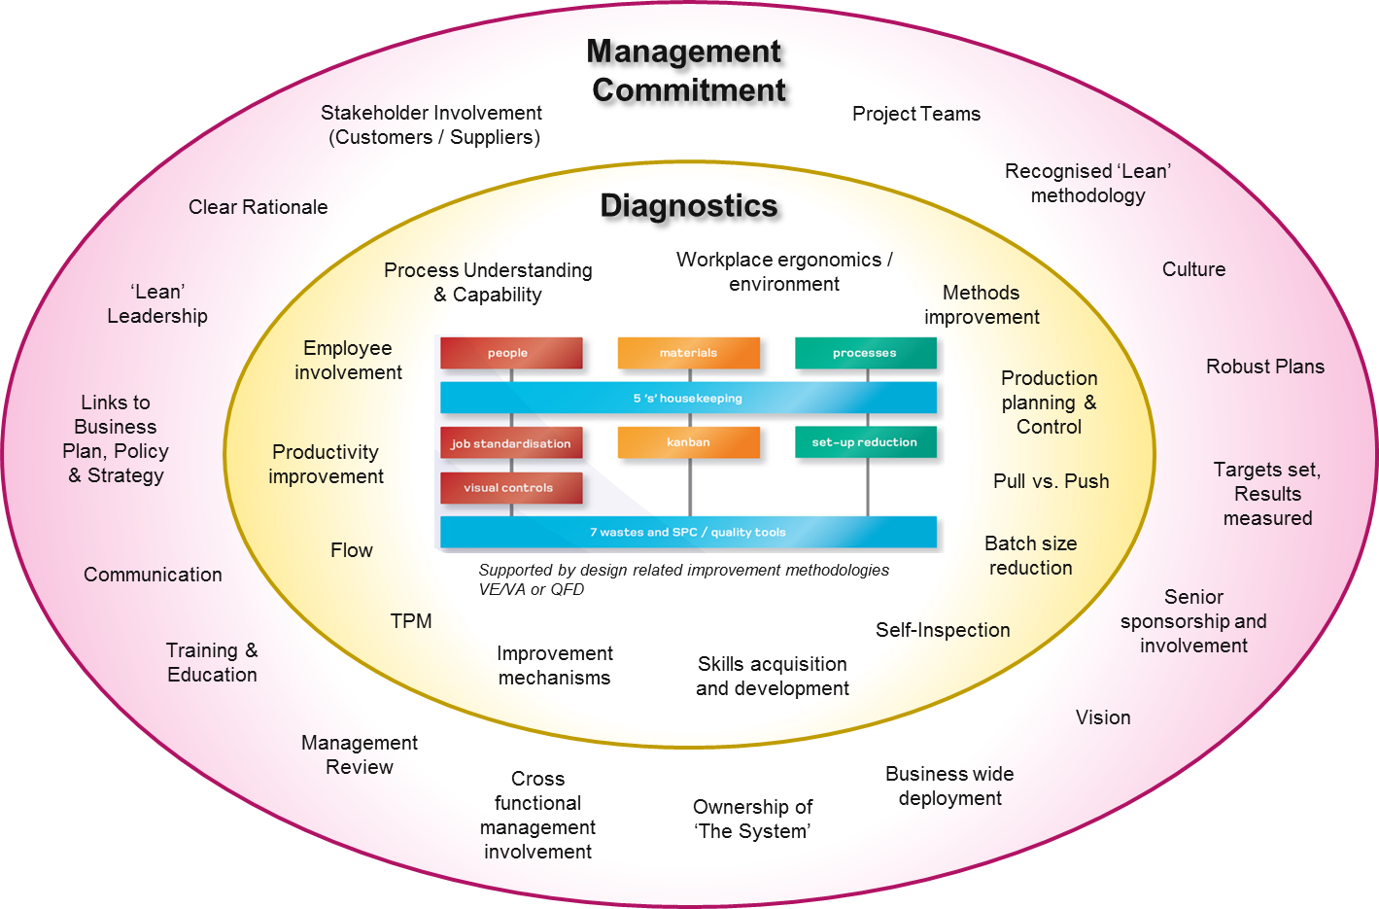

Figure 1: Manufacturing Excellence Lean Framework

The Manufacturing Excellence assessment is used to understand and support organisations who want to drive business results through Lean tools, techniques and philosophies.

There are two key elements of the assessment toolset:

* **Diagnostic -** The practical application of Lean in specific areas, usually Work Areas, Cells or production lines.
* **Management Commitment -** To understand how the organisation’s senior management team are enabling Lean and deriving business results across the boundaries of the company, including customers and suppliers.

## Assessment Team & Practitioners

For the purposes of conducting a Manufacturing Excellence Assessment recognised by the SC21 Programme, Practitioners must be fully trained and verified by the SC21 PDQ SIG, in accordance with the **SC21 Practitioner Requirements** Document. The structure of the practitioner training process is shown below:-

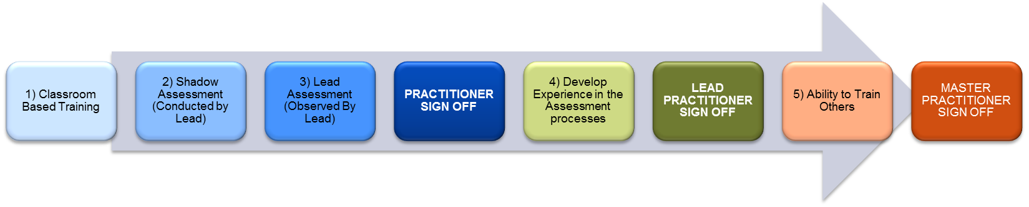

The minimum requirement is that a recognised Lead Practitioner forms part of the assessment team, under their guidance unqualified Practitioners may support the assessment, although they should have undertaken classroom based training modules before doing so. The current list of approved Practitioners can be found on the following SC21 website page: <https://www.sc21.org.uk/sc21-knowledge-providers/how-to-be-a-sc21-practitioner/>

It is possible to use this assessment toolset internally as part of the SC21 Lite process, however if the assessment is not conducted by a Lead Practitioner the assessment score is not admissible for SC21 recognition. *(Note: SC21 Lite is a self-assessment approach to SC21 encouraging the use of the assessment toolsets for self-driven improvement activity – see the SC21 website for more information)*

### Assessment Team Structure

The number of Practitioners involved in an assessment will depend on the size of the organisation and the recognition level to be achieved. It is recommended that a consensus approach is taken when conducting all assessments (a minimum of 2 Practitioners); this is to ensure the assessment scoring is conducted in a fair and balanced manner and the opportunity for individual bias is minimised. Where this is not practical however, and for larger, more mature organisations the minimum numbers mandated by the PDQ SIG are highlighted below:

|  |  |  |  |
| --- | --- | --- | --- |
| Company Size | Bronze | Silver | Gold |
| Small <50 employees | 1 | 1 | 2 |
| Medium <250 employees | 1 | 2 | 3 |
| Large >250 employees | 2 | 3 | 3 |

## Supporting Documentation

The following documents are required to undertake this process, they are designed to simplify and standardise the application of this assessment methodology for the purposes of this assessment process.

|  |  |  |
| --- | --- | --- |
| Document Title | Document No. | Purpose |
| Man Ex Assessment Tool | MxT01 | Practitioner assessment document and guidance to be used to conduct the Diagnostic and Management Commitment Assessments |
| Man Ex Scoring Workbook | MxT02 | Used to calculate the assessment scores and generate visual elements, charts and graphs for the purposes of initial feedback presentation, assessment reporting (Man Ex Feedback Template) and transfer to SC21 submission template |
| Man Ex Report Template | MxT03 | Used by Practitioners to generate the assessment report to feed back to the organisation. SC21 standard template. |

# Diagnostic Assessment



Figure 2: Manufacturing Excellence Diagnostics

## Scoring

The diagnostic is based on recognised core Lean tools and techniques. Each Diagnostic element is structured between ‘low adoption’ and ‘high adoption’ scenarios and given a score from 0 to 4 accordingly. Each diagnostic contains detailed expectations providing guidance to the Practitioner as to how the organisation should be scored.

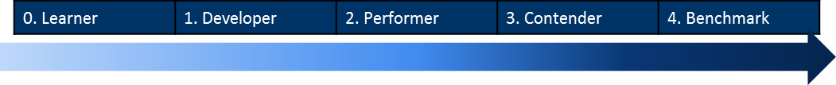

The maximum score from each diagnostic is 80 (20 boxes x 4points). If a particular element within the diagnostic is agreed as ‘not applicable’ it is not included in the scoring and the diagnostic is rated on a maximum score of 76 (or 72 if 2 boxes are excluded and so on).

## Application and Assessment Scope

The diagnostic is used in work areas or cells, the assessment should look to individually assess a number of work areas in order to gain a good overview of the range of capability and maturity across the organisation. This will typically mean assessing between 1 and 4 work areas depending on the size and complexity of the organisation. The Practitioner is responsible for determining the appropriate number of diagnostic assessments for any given organisation based on their experience. The specific cells to be assessed should be agreed between the organisation and the practitioner as part of planning the assessment.

Before conducting each diagnostic, the assessment process should be fully explained to the work area representative(s) by the Practitioner. The work area team should be given the opportunity to ask any questions relating to any part of the assessment process.

*The time taken to complete a diagnostic within each work area is usually between 2 and 4 hours.*

## Methodology for Performing a Diagnostic

The diagnostic is typically used in a systematic way, working through the assessment tool in order. Any of the items within the diagnostic that are agreed as not applicable to a certain area are not evaluated. For a diagnostic element to be considered not applicable it should be clear that there is no benefit the business could get from applying the principles of the tool in that area. Not simply that the business has chosen not to make use of that particular tool. Diagnostic elements should only be made not applicable by exception and it is the ultimate decision of the Lead practitioner to do so. A full explanation of why the diagnostic was deemed not applicable should be recorded in the final report.

Throughout the process any relevant terminology or points of interest should be explained. The check sheet and associated score is evaluated by looking for tangible evidence and listening to responses from questions. The Practitioner should take notes throughout the assessment, to assist in scoring and offering Opportunities for Improvement.

The scores given for each element are dependent on the degree of effective application. The “look fors” (contained within the detailed expectation sheets) can be used to explore further detail. They can also be used to provide additional Opportunities for Improvement and in some circumstances may have a bearing on the score – particularly if it’s judged the applicable “look for” has a strong or priority relevance to the area in question.

After each of the elements has been rated, an overall Diagnostic Score for the work area assessed is produced. These steps then need to be repeated on any further work areas / cells that have been agreed to be within the scope of the assessment.

The Practitioners’ experience should be used to ensure the Opportunities for Improvement offered are real and will drive Cost, Quality and Delivery improvements.

**Note:**

The terminology used within a Diagnostic may not align directly with the commodity, product or service being assessed. In these instances the Practitioner will need to interpret the diagnostic to match the situation and then provide realistic and valued feedback of Strengths and Opportunities for Improvement.

# Management Commitment

## Introduction

The Management Commitment element is focussed on understanding the managerial processes which enable Lean Operations within a company and what results are being achieved as a consequence.

To gain maximum benefit from the assessment process, and to help ensure consistency in the scoring methodology, the assessment and documentation should be supported by a presentation on management commitment to the organisation to provide examples of various approaches. This presentation should be provided either prior to or as part of the assessment workshop, as deemed appropriate by the practitioner based on the maturity of the organisation being assessed.

**Note**: Results assessed within Management Commitment are those achieved from implementation of a Lean philosophy and not those of the overall business.

## Management Commitment Self-Assessment (Optional)

This method should only be used for the purposes of self-assessment, either as part of “SC21 Lite” deployment or as a self-assessment prior to a Practitioner led workshop. It uses a simplified questionnaire approach allowing users who are not familiar with RADAR® scoring methodology to conduct a basic assessment.

The questionnaire comprises 23 questions which address the elements of the EFQM RADAR® concept:

|  |  |
| --- | --- |
| EFQM RADAR® Element | # of Questions |
| Approach | 6 |
| Deployment | 6 |
| Assessment and Refinement | 5 |
| Results | 6 |

The format follows the principle of that used in an EFQM Determining Excellence assessment where scoring is based on A, B, C, D or E and a percentage achievement attained which is multiplied by the weighting factor of 650 to give the Management Commitment score.

The results and output from this self-assessment can be used for an organisation’s internal improvement purposes or communicated to a Practitioner as input/additional information for a full assessment using RADAR® methodology. The results **cannot** however be used to support an SC21 award submission.

The assessment questionnaire for Management Commitment Self-Assessment is contained within the **Man Ex Self-Assessment Workbook MxT04** document.

## Assessment Workshop

The assessment ‘toolset’ for Management Commitment is based on the RADAR® concept associated with the EFQM Business Excellence Model. A copy of the EFQM Excellence Brochure ISBN: 978-90-5236-670-8 should be given by the Practitioner or bought by participating companies.

The assessment structure and “look-fors” for the RADAR® based assessment are contained within the **Man Ex Assessment Tool** document.

It is expected that the Practitioner delivering the assessment will be be experienced in the EFQM RADAR® approach, as it is necessary to understand the foundation of the assessment structure to facilitate the workshop.

Within the process there is an amount of flexibility regarding the allocation of scores allowing the Practitioners to exercise their experience, knowledge and judgement.

## The EFQM RADAR Model

The principle for the RADAR® method is described in below.

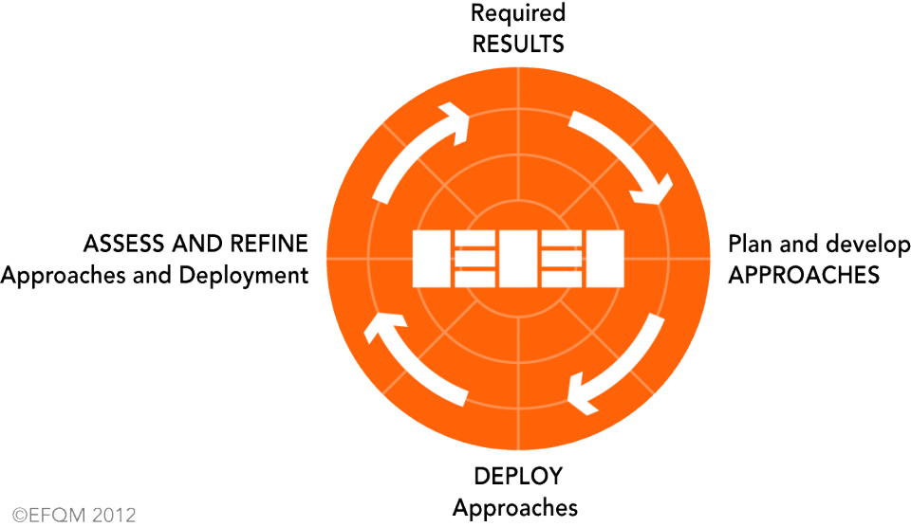

Figure 3: EFQM RADAR Model

### Enablers

An **Approach** is the overall way by which something is made to happen and comprises of processes and structured actions within a framework of principles and policies. The Approaches are **Deployed** in a structured way to ensure implementation. **Assess and Refine** ensures the Approaches and their deployment are achieving the desired **Results**.

Organisations are asked to provide evidence of how they address the activities relevant to Approach, Deployment and Assess and Refine.

### Results

The **Results** section measures the excellence and scope of what the organisation is delivering in terms of value to its stakeholders through Manufacturing Excellence.

## Methodology

The Management Commitment workshop is conducted by interview with a broad representation of an organisations senior management team (ideally the Board of Directors are involved). It is usually scheduled to take place after the work area diagnostic element, so that a comprehensive view of the practical deployment of Lean Manufacturing has taken place prior to interviewing the senior management team.

At the start of the interview, the process to be followed and the objectives should be explained. The Senior Management representatives should be given the opportunity to ask any related questions at any point during the interview.

The depth of questioning should be such that sufficient non-anecdotal evidence is collated to gain an understanding of the current situation. Using the information received (verbal/documented), notes should be taken by the Practitioner. These notes will assist in determining the score and defining strengths and Opportunities for Improvement.

*The time taken to complete a management commitment workshop is usually around 3 to 4 hours.*

Scoring should be conducted following the interview process using the **Man Ex Scoring Workbook MxT02**. Where there are multiple Practitioners conducting the interview, scoring should be discussed to achieve consensus wherever possible; however, the Lead Practitioner should have the final say.

When the scores have been determined for both Enablers and Results, an overall Management Commitment score can then be produced. The maximum score available is 100 for Enablers and 100 for Results (200 in total). In conjunction, and more importantly, Opportunities for Improvement should be established which the organisation can consider for inclusion in their Continuous Sustainable Improvement Plan (CSIP).

# Outcome of the Manufacturing Excellence Assessment

The key output of both the Diagnostic Assessment and Management Commitment Assessment are Strengths and Opportunities for Improvement.

* **Strengths** can be used as standards or examples of best/good practice and cascaded to other cells or parts of the business.
* **Opportunities for Improvement** can be analysed for:
  + benefit to the business
  + actions planned or taken
  + incorporated in the CSIP

It may be appropriate to note “Comments” for activities that have started recently or need further deployment.

## Assessment Scoring

The overall assessment score is calculated automatically by the **Man Ex Scoring Workbook**, however the methodology behind the calculations is shown below.

**Diagnostic Assessment**

(35% Weighting)

Cell 1 44 / 80

Cell 2 44 / 76

Cell 3 42 / 80

**Diagnostic Score = 130 / 236 x 350 = 192**

**Management Commitment**

(65% Weighting)

Enablers 37.5 / 100

Results 19 / 100

**Management Commitment Score = 56.5 / 200 x 650 = 184**

**Total Manufacturing Excellence Score = 192 + 184 = 376**

The example above demonstrates how the scores from the Diagnostic (35%) and the Management Commitment (65%) Assessments are combined to produce one overall score for Manufacturing Excellence.

## Initial Feedback Presentation

Where feasible, a feedback presentation should be compiled by the Assessment Team and presented to the organisation’s key stakeholders immediately following the assessment. Where it is not possible to provide the presentation in person, the presentation should still be created and sent to the organisation as a priority.

This presentation should contain as a minimum:

* Summary Strengths and Opportunities for Improvement for both the Diagnostic and the Management Commitment Assessments
* Assessment scoring (Diagnostic Scoring, Management Commitment Scoring and Overall Score).

The **Man Ex Scoring Workbook MxT02** provides formatted outputs suitable for use in a presentation document.

## Feedback Report

In addition to the initial feedback presentation, a detailed assessment report will be prepared by the Assessment Team. The Lead Practitioner will collate the final version and send to the organisation. The **Man Ex Report Template MxT03** should be used as the standard format for all assessment reports carried out under the SC21 programme.

The Feedback Report contains:-

* **Diagnostic Assessment:**
  + Diagnostic Check-sheet Summary for each cell assessed with high level Strengths, Opportunities for Improvement and Comments if required
  + Detailed Strengths, Opportunities for Improvement, Comments and Scoring for each work area assessed covering all diagnostic elements
  + Diagnostic Scoring Summary with scoring graphs
* **Management Commitment Assessment:**
  + Management Commitment, Strengths, Opportunities for Improvement, Comments and scoring for Enablers and Results
  + Management Commitment scoring summary with scoring graphs
* **Overall Assessment Score**
* **Benchmarking**

*The Assessment Report should be sent to the company within three weeks of the workshop.*

## Benchmarking

The score and feedback can be used for future target setting and benchmarking (as below). *The latest update of the benchmarking data can be obtained from the SC21 Project Office.*



# Preparing for a Manufacturing Excellence Assessment / Summary

Preparation by the Practitioner(s) is fundamental to deploying the Manufacturing Excellence assessment process successfully. It ensures that all the right people have an input and all the appropriate information is available and understood.

Below are the suggested preparation steps: -

|  |  |  |  |
| --- | --- | --- | --- |
| Step # | Assessment | Description | Responsibility |
| 1 | General | SC21 and Manufacturing Excellence Awareness Presentations to the organisation | Lead Practitioner |
| 2 | Diagnostic | Agree work area(s) to be assessed and identify representatives of the organisation who will participate | Organisation and Practitioner(s) |
| 3 | Management Commitment | Agree representatives of the organisation who will participate  Organisation to complete a self-assessment using the Self-Assessment Workbook (optional) | Organisation and Practitioner(s) |
| 4 | General | Consider other SC21 stakeholders and key customers by referring to the SC21 National Status Report and agree their role in supporting the assessment where appropriate | Organisation and Practitioner(s) |
| 5 | General | Obtain relevant information relating to doing business with the organisation:   * Product Ranges and Build Rates * Scope of business * Performance information (Delivery and Quality) * Issues / Concerns * Ongoing Improvement Activities | Practitioner(s) |
| 6 | General | Prepare Manufacturing Excellence Material:   * SC21 Overview * SC21 Manufacturing Excellence Overview * Assessment Material including self-assessment if required * Management commitment presentation and examples (depending of organisations maturity) * Initial Feedback Presentation * Assessment Scoring Workbook * Assessment Report Template | Practitioner(s) |

## Manufacturing Excellence Self-Assessment (SC21 Lite)

For the purposes of SC21 Lite, a self-assessment workbook is available **(Man Ex Self-Assessment Workbook MxT04).** This workbook is designed to allow users to score themselves using the diagnostic section of the **Manufacturing Excellence Assessment Tool MxT01** and contains a simplified self-assessment version of the Management Commitment Assessment using A-E scoring as opposed to RADAR scoring as described earlier in this process guide.

The results and output from this self-assessment can be used for an organisation’s internal improvement purposes, however **cannot** be used to support an SC21 award submission.