SC21 Relationship Excellence (RelEx) Framework

Process Overview

RxP02 Rev D (c)
Dated July 2019

Acknowledgement
The scoring methodology used by Relationship Excellence is based on the RADAR scoring methodology. ADS acknowledges the contribution made by the Institute for Collaborative Working (ICW) and the permission of BSI to allow the use of aspects of BS11000 within this model

Prepared by: The SC21 Performance, Development and Quality Relationship Excellence Special Interest Group (PDQ RelEx SIG)

Document Contents

1. Introduction 3
2. Principles of the SC21 Relationship Excellence (RelEx) Framework 3
3. SC21 Assessment Approach 4
4. Self - Assessment 4
5. Practitioner Assessment 4
6. Launch meeting 5
7. Feedback 5
8. Detailed Report 5
9. Relationship Excellence Framework (RelEx) 6
10. RelEx Scoring Mechanism 14
11. Performance Standards Criteria 14

Introduction
Collaborative business relationships have been shown to deliver a wide range of business benefits including enhanced competitiveness and performance while adding value to organisations of all sizes. The publication of BS11000 presented organisations with an opportunity to adopt a consistent framework approach to address collaborative business relationships. The standard now migrates to the international standard ISO 44001, demonstrating that collaborative working is no longer a localised activity and is in fact an international opportunity.
The SC21 Relationship Excellence (RelEx) Framework assessment has been developed using the knowledge and principals from the ISO-BS standards and is designed to support organisations who want to drive business results through the development of a collaborative working approaches using relationship lean tools, techniques and philosophies.
The SC21 Relationship Excellence (RelEx) Framework assessment is used to understand how the organisations senior management team are enabling collaborative working and deriving business results across the boundaries of the company, including customers and suppliers.
SC21 Relationship Excellence (RelEx) Framework has been designed to allow organisations to use:-
- as a self-assessment methodology
- by SC21 RelEx Practitioners
- any other SC21 stakeholder

Principles of the SC21 Relationship Excellence (RelEx) Framework
SC21 Relationship Excellence (RelEx) Framework is intended to embed a collaborative working approach in an organisation; in just the same way as the Manufacturing Excellence Framework is designed to embed a lean approach within a business.
RelEx will not simply be asking suppliers to “undertake more RMRs” (Relationship Management Reviews), rather embed and deploy appropriate collaborative working practices and principals within the organisation. RelEx will allow companies to develop appropriate approaches to each of their relationships – some which will require a very close collaborative approach, others which are more “arms-length” albeit with good behaviours embedded.
RelEx “plugs the gap” in SC21 where “ability to form effective relationships” is not mandated, assessed or part of the SC21 diagnostics tool kit and SC21 performance standards criteria.
RelEx provides a framework for a company’s ability to work collaboratively. It is a measure of the company’s collaborative capability that is comparable to Manufacturing Excellence and Business Excellence.
RelEx has been brought into the SC21 performance standards criteria; it will formally assess a supplier’s collaborative capabilities as part of performance standards criteria for Silver and Gold levels. It is not mandatory for Bronze.
RelEx does not replace the SC21 Relationship Management Review process – in fact the RMR is a tool that sits within the RelEx Process criteria 5, 6 and 7 below, where appropriate.

SC21 Assessment Approach
The SC21 Relationship Excellence (RelEx) Framework may be completed as self-assessment by the organisation or preferably within a workshop facilitated by SC21 accredited Practitioner(s); this is the recommended SC21 approach to assess an organisation against the RelEx criteria. To achieve SC21 performance standard criteria the RelEx must be assessed by an accredited SC21 RelEx Practitioner.

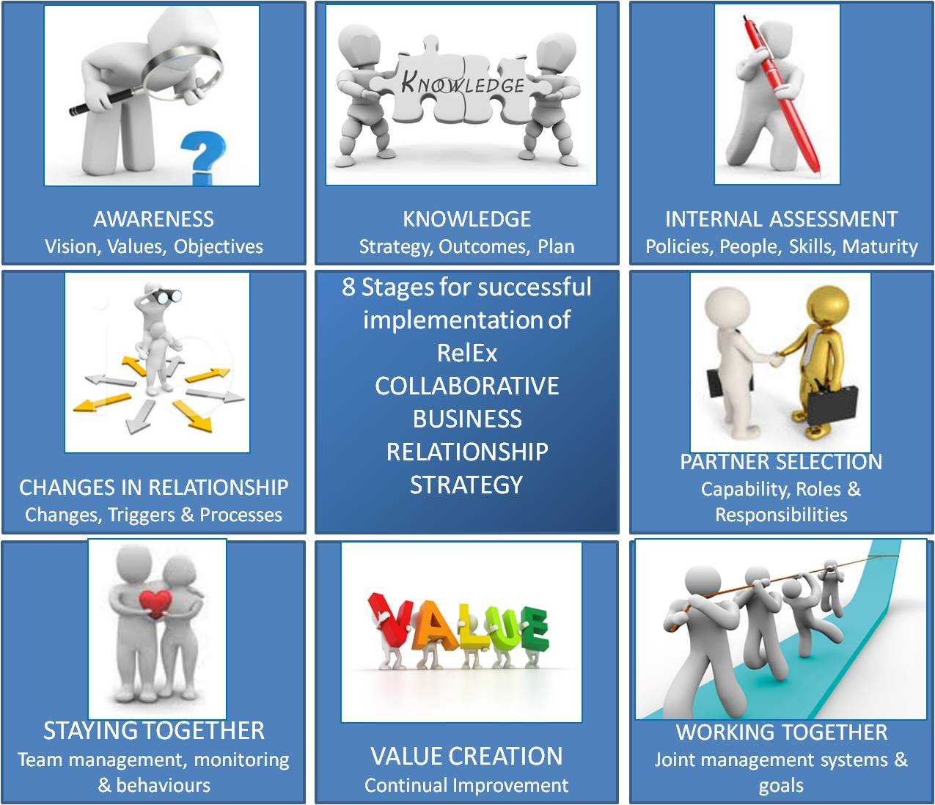

Self - Assessment
Any organisation can conduct a self–assessment using the guidance in this framework and the RelEx workbook; this is in line with the SC21 light approach used in the other SC21 diagnostic tools. Self-assessment is not part of the final submission criteria and any submission must be supported by a full RelEx assessment by an approved RelEx Practitioner.

Practitioner Assessment
In order to obtain a SC21 performance standard recognition the assessment shall be carried out by a SC21 accredited RelEx Practitioner. The assessment at the organisation’s facility is essentially a discussion to understand the background, scope and to validate any self-assessment scoring that has taken place.
The organisation is expected to present evidence where necessary against each criterion. In some cases the organisation will have scored themselves higher/lower than that merited. There may be a need for the practitioner to align scores against the scoring criteria. Practitioners will use their experience effectively throughout the deployment of the Relationship Excellence Framework.

Launch meeting
The Assessment Practitioner(s) will present an awareness overview to the organisation’s leadership team. The presentation should cover:-
- An overview of RelEx.
- Scope of the assessment
- SC21 use of the RelEx framework (workbook) and Scoring.
- Agreement of a date for the facilitated workshop where the Practitioner(s) will review the scoring with the key stakeholders.
- Agreement of a date for the delivery of feedback and report detailing Strengths, Areas for Improvement and the RelEx score.

Feedback
Practitioner(s) will prepare a presentation as feedback of Key Strengths and Areas for Improvement as ‘Key Themes’ and the comparable Relationship Excellence Score.
The Overview Presentation and Score Feedback timing will be agreed by the Practitioner and the Organisation – on the day, the next day or at another agreed date.
As a guide – scores within the bands of “A” or “B” are typically indicators of Strengths, scores of “C” can be developed or deployed further and scores within the bands of “D” and “E” are indicators of Areas for Improvement which can be summarised under each Criteria.
The information within the feedback will provide input for the Organisation’s Continuous
Sustainable Improvement Plan (CSIP).

Detailed Report
The detailed assessment report will be prepared by the Practitioner(s); the Practitioner will collate the final version for transmission to the Organisation.
The report should be segmented by criterion and contain the agreed detailed scoring within the bands (A, B, C, D or E) of each question together with Strengths, Comments (to address scores of C) and Areas for Improvement by criterion.
The Report will finish with the summary of scores by criterion and the comparable Relationships Excellence Score.
The Feedback Report should be sent to the Organisation within two weeks of the workshop.

Relationship Excellence Framework (RelEx)

Awareness
The first stage in the RelEx is the raising of awareness within the organisation so that the basis for proceeding is established.
An organisation should appoint a senior manager to be responsible for the development and implementation of Relationship Excellence.
The appointed person should have the responsibility and authority to establish policy, process, culture and behaviours to establish the forum for deployment of collaborative working.
There should be clear defined objectives and an integrated business case. An initial risk assessment undertaken to identify, reduce or mitigate collaborative relationship risks.
The functions of Leadership include:
- Direction Setting
  - Designed to create the vision and strategy
- Alignment
  - The leader lines up all the relevant stakeholders with the vision and strategies previously created
- Motivating and Inspiring
  - Inspiring people to achieve the vision no matter what the obstacles

WHAT | WHY | POTENTIAL EVIDENCE
Senior Leader appointed | Ensure authority in place to adopt collaborative approaches | Minutes of executive meetings and allocation of responsibility to Leader
Defined policy for collaboration | Clear guidance in place for consistent operations | Documented policy statement for collaborative working
Strategic business objectives | Operational links to business benefits | Review of company business plans and objectives
Recognised value of collaboration | Identifiable value for alternative working | Business development strategy to deliver objectives
Segregated relationships | Clear focus on where collaboration will add value | Review of business relationships and prioritisation
Policies and procedures to support competences and behaviours | Ensure that personnel have appropriate capabilities, training and behaviours | Staff assessment and skills development where appropriate to meet the needs of a collaborative working approach
Documented risk assessment incorporating collaborative working | Identify the additional risk that interdependence can create | Review of company risk management approach
Implementation strategy for each relationship type selected | Clearly define guidance for each relationship to achieve goals | Clearly defined engagement model to take collaboration forward
Documented procedures | Auditable approach to ensure effective operations & consistent instructions for implementation of collaborative approaches | Process model or auditable manual that can be reviewed and updated to demonstrate effective relationship management
Strategic Relationship Management Plan (SRMP) | Define the business approach to each type of relationship | Deployed Strategic Relationship Management Plan (SRMP)

Knowledge
An approach to develop knowledge and understanding is required to inform the strategy and business approach for collaborative opportunities.
This includes the development of the appropriate processes, tools, resources and capabilities to carry out collaborative working. There should be a risk management plan.
It may be at this stage it is identified that a collaborative approach is not appropriate for the opportunity identified.

WHAT | WHY | EVIDENCE
Establish the objectives & evaluate if collaboration is appropriate. | Not all business relationships will lend themselves to a collaborative approach efforts should be focused on outcomes | Business development / sales plans & Bid /no Bid processes reflect consideration for collaborative approaches
Identify the experience, skills & competencies of individuals | Collaborative working may not suit all staff and some may need development | Consideration where practical to assign most suitable staff to work on collaborative programmes
Establish how to manage & share knowledge within relationships | Sharing knowledge is a key benefit but it also needs to be controlled in a collaborative environment | Recognition of information management such as Intellectual Property Rights (IPR) and what may or may not be shared with partners business cases or bidding strategies that collaboration has benefits
Established business case for collaborative working | Investment in collaborative working needs to match benefits | Strategies identify clear objectives and outcomes
Identify objectives of each relationship | Validating specific objectives to create appropriate focus | Risk management approach takes into account relationships as a potential risk (including Internal improvement plans)
Integrate relationship management into established overall risk management (external/internal) | To ensure that relationships are recognised as potential risks as well as benefits (internally and externally) | Risk management processes and assignment of responsibilities to appropriate individuals
Regularly review the implementation plan | To ensure that collaborative approaches are maintained and appropriate | Regular management review processes

Internal Assessment
This is where the organisation identifies if it is ready to support a collaborative approach. Effective leadership is crucial for maintaining a clear focus, to support the culture that supports the collaborative relationship behaviours.
The organisation must understand its own internal capabilities before defining that of any external partner. The organisation must identify potential constraints and review these periodically.
Organisation must establish corporate visions and values and these support collaborative working relationships.
The appropriate relationship is defined, taking into account the willingness of the partner to collaborate.
Is the action plan sound in its approach and reflects the current situation?
Have any training opportunities been identified?

WHAT | WHY | EVIDENCE
Establish policies & process to manage collaboration | To ensure there is clarity on the acceptability of collaborative working and processes to support | Company policies and processes incorporating collaborative approaches
Identify potential constraints & periodically review | To ensure that any internal processes are adapted to support collaborative working when appropriate | Internal continuous improvement programme, review processes that including SWOT, Pestle etc.
Establish a collaborative profile and monitor effectiveness | To understand internal limitations that may need to be changed and external profile / perceptions | Internal reviews and Business development surveys /customer feedback reviews
Identify the level of knowledge & skills and suitable staff development or recruitment | To establish and address skills development needs for existing staff and possible criteria when recruiting | Individual staff assessments/appraisals/job descriptions recognise collaborative skills & staff training programmes
Undertake regular reviews of suitability & effectiveness of collaborative approaches | Management need to ensure their approaches remain appropriate for the business | Management review processes incorporating a focus on collaborative working and feedback from partners
Updated the SRMP to incorporate output of internal assessments | To ensure that operating practices and development plans incorporate development needs | Implementation instructions / project plans incorporate any specific development needs

Partner Selection (Assessment)
The potential collaborative working capabilities of the candidate partner organisation (customer, partner or suppliers) are well understood and assessed regularly.
It is important to establish clear objectives, expectations of each potential partner.
What does the ideal partner profile look like? Are there established partner selection criteria?
Where the choice of partner is restricted or customer driven, assessments should still be carried out to identify strengths and weaknesses of the relationship and establish the needs of the customer.

WHAT | WHY | EVIDENCE
Identify potential collaborative partners and establish internal agreement for the collaborative approach | To understand and agree internally who would be potential collaborative partners whether Customers /suppliers/partners | Internal assessment of partner’s strengths and weakness relative to collaborative working possibly Bid /no bid process or supplier evaluation
Ensure partner selection process incorporating defined partner selection criteria | To have a structured approach for collaborative working that ensures selection is proactive and benchmarked | A definition of the relationship type and evidence of a review process that supports the selection of partner
Establish common objectives of both organizations | To ensure there is compatibility between the objectives of the parties | Evidence that the parties have shared and jointly reviewed their individual objectives. (Relationship charter)

Working Together
The emphasis here shifts from the initiating organisation to that of the potential partner. Both parties must have the ability to develop a joint approach, with reviews and development undertaken where it is appropriate and mutually agreed (e.g. strategically important relationship).
Relationships should be regularly reviewed and acted upon at joint progress/business reviews. Where appropriate and beneficial, a process such as RMR, 360 degree etc. is in place). SC21 Relationship Management Review (RMR) activity will be the preferred method here. RMR’s with each appropriate relationship using the SC21 Relationship Measurement Matrix (RMM) tool, however other tools are acceptable.
The Strategic Relationship Management Plan is in place and recorded on the Continuous Sustainable Improvement Plan (CSIP). This is supported by individual Relationship Management Plans (RMP) for each appropriate relationship.
A focus on collaborative improvements is the key to working together:

WHAT | WHY | EVIDENCE
Charter | Charter | Charter
Identify the Leader for each organisation (as appropriate) | Ensure there is executive support in place | Evidence of agreement for executive involvement
Validate the key objectives & principles of the collaboration | Ensure there is joint agreement to the objectives and principles for collaboration (as appropriate) | Collaborative principles and behaviours or MOU or contract
Undertake a competency appraisal and appoint collaborative team leader(s) | Ensure that the leadership taking the collaboration forward is suitably experienced | Evidence of a review where the leadership in all parties are recognised to have the appropriate skills
Review Joint objectives & effective measurements | To ensure the delivery team has clarity & measurement | Performance measures (Q&D etc) identified and in place and reviewed with benchmark
Define roles and responsibilities for the team | To ensure the team members understand their roles | Clearly defined Roles & Responsibilities within the contracting agreements
Establish a joint knowledge management plan | To agree what knowledge needs to be shared | Jointly agreed knowledge management process
Establish communications management across all stakeholders | To ensure those outside the team understand the activities in the context of their organisations | Evidence that the activities of the collaboration are appropriately communicated across the organisation
Establish joint Risk Management processes including joint risk register | Ensure that all risks are identified and jointly managed to the benefit of the project or programme | Evidence of a joint risk register that is regularly reviewed and appropriately addressed by the joint management representatives
Undertake a joint business process review & implement process improvements as appropriate | Ensure there are no unmanaged gaps in the processes or where possible improvements can be made | Evidence that the organisations have where appropriate reviewed and agreed processes for improvement
Governance | Governance | Governance
Undertake internal assessments at planned intervals | To regularly review the operating practices to ensure focus | Periodic reviews by the joint management team (see Value creation)

Value Creation
This stage is about establishing the process for creating value through collaboration and alignment to bring additional benefits. Continual joint value improvement should be established between the parties to enable qualitative and quantitative value measures to be agreed. Performance against these measures shows sustained performance or improvement over a period of time.
Definitions of value should have been identified with your partners. This may be determined using the SC21 RMR Process.
When discussing Value the practitioner should always remember the Principles of Lean;
The five-step thought process for guiding the implementation of lean techniques is easy to remember, but not always easy to achieve:
  - Specify value from the standpoint of the end customer by product family.
  - Identify all the steps in the value stream for each product family, eliminating whenever possible those steps that do not create value.
  - Make the value-creating steps occur in tight sequence so the product will flow smoothly toward the customer.
  - As flow is introduced, let customers pull value from the next upstream activity.
  - As value is specified, value streams are identified, wasted steps are removed, and flow and pull are introduced, begin the process again and continue it until a state of perfection is reached in which perfect value is created with no waste.

WHAT | WHY | EVIDENCE
Establish, implement, record and review what each party believes value improvement is delivering to the relationship | To ensure that the value created through a collaborative approach is recognised and recorded | This can be initiated through the deployment of a joint RMR to identify areas for improvement and value register
Establish improvement teams as required | To promote a collective approach to address problems and opportunities | Evidence of organisations jointly approaching improvement programmes
Identify issues and areas of improvement and metrics to monitor performance | To create a focus within the collaboration to identify opportunities & continuous improvement | Evidence records of improvements being identified and measured versus plan
Establish a process to ensure learning from experience | To ensure that organisations gain by learning from their experience working together | Evidence of a lessons learned process being managed and where appropriate incorporated.
Establish mechanisms for generating ideas and innovations to develop the collaborative relationship | Ensure there is an appropriate process in place to encourage and capture innovation through the collaboration | Evidence that innovation is encouraged and monitored by the joint management team
Update Strategic Relationship Management Plan (SRMP) as necessary | Update SRMP as necessary | Updates to the SRMP /contract or operating processes

Staying Together
A continuous relationship improvement process is established and embedded into the relationship and provides on-going mutual benefits.
There is development of a dispute resolution (escalation) process.
The planned follow up may be conducted using the SC21 RMR activity (this would be seen as best practice). Re-measurement of the relationship using the SC21 RMM as the appropriate tool for best practice should be discussed and agreed.

WHAT | WHY | EVIDENCE
Establish process to monitor measure & review performance including outputs, risk, alignment, behaviours and trust | Ensure that the performance of the collaboration is measured appropriately and includes behavioural aspects to build trust | Minutes of joint management meetings reflecting key issues and periodic utilisation of the SRMP to maintain a focus on optimising the relationship
Ensure on-going joint management of activities in accordance with objectives and governance | To ensure that the joint management of the collaboration delivers the agreed objectives and contractual requirements | Outputs from joint management meetings and performance monitoring of contract requirements
Regularly monitor and review Value creation and continual innovation | Ensure the focus is maintained on innovation and value creation | Value creation register or minutes of joint management meetings
Monitor issues related to Behaviours and Trust | To ensure that over time the behaviours are maintained to support a growth in trust | Review or RMM or other behavioural monitoring programmes
Maintain a clear focus on delivering agreed performance by each party | Ensure that the prime objectives and deliverables are maintained towards successful outcomes. | Review of performance reviews or progress reports including risk reviews
Establish Leader reviews of monitoring, measurement & performance | Ensure that Leaders are kept informed and offer support where necessary | Evidence of executive reviews
Establish & maintain process for issue resolution | Ensure that issues are effective resolved in a timely manner | Issues register
Establish & maintain a Relationship Change strategy | Ensure the parties are jointly aware of potential changes to relationship | Evidence that strategy is periodically reviewed and updated as necessary
Regularly maintain Relationship Management Plans and SRMP | Ensure operating practices are maintained | Updates to SRMP/RMP as necessary

Changes in Relationship
Changes in relationships should be considered and jointly planned for at the earliest stages of the relationship. By having a clearly defined growth/disengagement process, organisations can increase openness and honesty in the relationship. It is recognised that changing market dynamics over time may require either party to want to break or change the relationship for its own benefit.
If a business relationship needs to expand through growth, new projects, or partnerships, or if a business relationship comes to an end (e.g. project is over, volume production moves to spares supply, business evolves into another type of business such as joint product development) then both parties may be able to adjust the relationship appropriately to ensure good terms are maintained and help any future engagement.
Both parties will need a mechanism or process to change the type of relationship that they are currently in, either further collaborative working or dissolve and rebuild the type of relationship for their mutual benefit.
Market dynamics change over time and the present relationship may no longer be appropriate or required. Re-assessment of the relationship must be regularly made to see if it is still mutually beneficial. Factors may include the end of current projects, moving from production to product support and new product introduction.

WHAT | WHY | EVIDENCE
Maintain a strategy (where applicable) | To ensure the partners understand the implications and actions required on completion of current activity or market changes | Review of a strategy
Regularly evaluate changes in the organization, business environment, personnel & performance impacts on the relationship | To ensure the parties effectively consider and communicate to each other any changes that may impact the relationship | Review of management meetings that reflect considerations which may impact on the current activity
Assess operations and potential developments in key areas which may lead to controlled changes in relationship | Ensure clarity and transparency by jointly agreeing any specific change plans to ensure business continuity and a future sustainable relationship | Strategy reviews and management meetings
Incorporate into change strategy business | To promote a collaborative approach to address any necessary transition impacting the businesses | Evidence of management meetings and development of change planning
Consider future opportunities for the relationship | To maintain a focus on the current relationship as a platform for future business opportunities | Evidence of the parties evaluating future business or extensions of current contract activity
Update RMPs/SRMP to reflect key issues of change strategy | Update the RMP/SRMP as a basis for future engagements | Joint maintenance of the RMP from a one to one relationship

RelEx Scoring Mechanism
Each element of RelEx should be assessed against the maturity matrix. Each of the 8 sections needs to be assessed and evidenced by an accredited RelEx practitioner according the scoring levels below. This approach is consistent with the Manufacturing Excellence and Business Excellence frameworks and has been designed using similar principles e.g. using “partial deployment” terminology and using guidelines for the length of time of embedding for each maturity level.
The maximum score available is thus 800.
This score is then multiplied by 1.25 to give a score out of 1000 to bring it in line with the SC21 Manufacturing Excellence Model.

Performance Standards Criteria
In order to be consistent with the Manufacturing Excellence Framework, SC21 performance standards will be based on achieving the following maturity levels (in addition to the existing performance criteria and maturity levels):
- Bronze – Not Mandatory but Assessment is recommended for inclusion into the CSIP (i.e. self-assessment and/or formal assessment undertaken and improvement actions identified in the CSIP)

- Silver – > 400 points

- Gold – > 500 points

