

|  |
| --- |
| **Company Name** |
| SC21 Manufacturing Excellence Assessment Report |
| **Document Reference – MxT03**  **Version – 2**  **Issue Date – July 2019**  **Assessment Date: [Pick the date]**  Assessor Name(s) |

# Document History

|  |  |  |  |  |
| --- | --- | --- | --- | --- |
| Date | Version | Author(s) | Summary of Changes | Approved by |
| May 2019 | A | Ross Harrison | New Document to Standardise report writing | PDQ SIG |

# Scope of Applicability

|  |  |  |
| --- | --- | --- |
| SC21 Lite | SC21 OE | SC21 C+G |
| Y | **Y** | **N** |

# Associated Documents

|  |  |
| --- | --- |
| Document Title | Document No. |
| Manufacturing Excellence Process Guide | MxP01 |
| Manufacturing Excellence Assessment Tool | MxT01 |
| Manufacturing Excellence Scoring Workbook | MxT02 |

# Contents

Document History 1

Scope of Applicability 1

Associated Documents 1

Contents 1

Introduction & Approach 3

Deployment 4

Section 1 – Cell Diagnostic Assessment 5

Diagnostic Scoring by Cell 5

Cell 1 Scoring 5

Cell 2 Scoring 6

Cell 3 Scoring 6

Cell 4 Scoring 7

Detailed Diagnostic Feedback 8

DIAGNOSTIC 1: Production / Service Planning 8

DIAGNOSTIC 2: Visual Control - Delivery Schedule Achievement 9

DIAGNOSTIC 3: Visual Control - Non-conformance 10

DIAGNOSTIC 4: Visual Control - Improvement Activities 11

DIAGNOSTIC 5: Visual Control - Skill Matrices 12

DIAGNOSTIC 6: 5S Workplace Organisation 13

DIAGNOSTIC 7: Set-Up Reduction 14

DIAGNOSTIC 8: Standardised Job 15

DIAGNOSTIC 9: 7 Quality Tools 16

DIAGNOSTIC 10: Statistical Process Control 17

DIAGNOSTIC 11: Overall Equipment Effectiveness (OEE) 18

DIAGNOSTIC 12: Productivity Improvement 19

DIAGNOSTIC 13: 7 Wastes - Processing 20

DIAGNOSTIC 14: 7 Wastes - Movement 21

DIAGNOSTIC 15: 7 Wastes - Transportation 22

DIAGNOSTIC 16: 7 Wastes - Defects 23

DIAGNOSTIC 17: 7 Wastes - Waiting Time 24

DIAGNOSTIC 18: 7 Wastes - Inventory 25

DIAGNOSTIC 19: 7 Wastes - Overproduction 26

DIAGNOSTIC 20: Kanban 27

Diagnostic Scoring Summary 28

Graph of Diagnostic Scores (By Cell) 29

Graph of Diagnostic Scores (Average vs. Target) 30

Section 2 – Management Commitment 31

Management Commitment Enablers 32

Approach 32

Deployment 33

Assessment and Refinement 34

Management Commitment Results 35

Relevance and Usability 35

Performance 36

Management Commitment Scoring Summary 37

Overall Score 38

Appendices 40

# Introduction & Approach

This Assessment Feedback Report details the findings of the Manufacturing Excellence Assessment which took place at the company facility in Company Site Location.

#### Assessment Scope and Structure

This Manufacturing Excellence Assessment was conducted by Lead Assessor Name (Lead Assessor), Other Assessor Name and Other Assessor Name . It covered the following cells / areas of the organisation – List Cells Assessed. The format for the assessment was interview and discussion with a group of personnel representing various levels of the organisation including; senior management, supervisors and operatives. The assessment was conducted using the Manufacturing Excellence 'Diagnostic' and 'Management Commitment' Toolset.

#### Assessment Context

This Report provides a general commentary on the Organisation’s application of Lean and detailed commentary on associated Strengths and Opportunities for Improvement. The Report also provides an overall score for the assessment as well as detailed scores for each of the Diagnostic and Management Commitment elements.

#### Assessment Approach

The SC21 Manufacturing Excellence Lean Framework which comprises the Diagnostic Matrix and Management Commitment Assessment (with EFQM RADAR Scoring) was used as the assessment template for this activity.



Figure 1: Manufacturing Excellence Lean Framework

# Deployment

The deployment of the activities identified this report will need to be managed through a dedicated plan, the Continuous Sustainable Improvement Plan (CSIP). It is important that this demanding activity is achieved in a measured and structured way. Focus on the areas of greatest benefit will be needed to ensure time and resource is used as effectively as possible.

#### Prioritisation Matrix

It is recommended that the Opportunities for Improvement contained in this report be reviewed against a ‘Prioritisation Matrix’, and therefore ranked before being included in the CSIP. It is important to remember that the CSIP needs to be balanced, selecting all the “easy” activities may result in a plan that is easy to implement and achieve but it may not result in much benefit to the organisation overall. Likewise selecting all the difficult/long term activities could possibly result in a plan that stagnates and de-motivates those involved through lack of tangible progress and benefits.

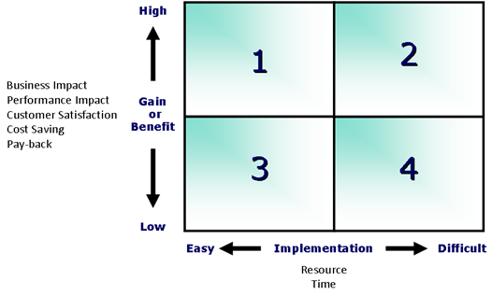

Figure 2: CSIP Prioritisation 4 Box Model

# Section 1 – Cell Diagnostic Assessment

#### What is the Diagnostic Assessment?

The 20 element Manufacturing Excellence ‘Diagnostic’ assessment follows a consistent framework, reflecting the maturity of deployment of the various improvement Tools & Techniques.

It is accepted that the terminology used within a Diagnostics may not align directly with the commodity or service being assessed. The diagnostic must be interpreted appropriately to match the situation in order to provide realistic and valued feedback of Strengths and Opportunities for Improvement.

The key outputs of the Diagnostic assessment are Strengths and Opportunities for Improvement. Strengths can be used as standards or examples of best/good practice and cascaded to other cells or parts of the business. Opportunities for Improvement can be analysed for benefit to the business, action taken and incorporated in the CSIP.

## Diagnostic Scoring by Cell

### Cell 1 Scoring



### Cell 2 Scoring



### Cell 3 Scoring



### Cell 4 Scoring



## Detailed Diagnostic Feedback

### DIAGNOSTIC 1: Production / Service Planning

How the production/delivery plan is generated and is integrated with other systems and processes.

|  |  |  |  |  |
| --- | --- | --- | --- | --- |
| 0. Learner | 1. Developer | 2. Performer | 3. Contender | 4. Benchmark |
| Load & Capacity planning / Project Management is ad-hoc or not effective – reactive only | Basic planning / Project Management approach, little cross functional engagement  Some consideration given to capacity at a high level | Average planning / Project Management approach, some cross functional engagement  Key aspects of Sales and Operations Planning considered, perhaps managed in offline system  Critical path activities understood | Sales and Operations Planning well considered and utilised with some visual management.  Well integrated with core business system  Good cross functional engagement  Clear understanding of load & capacity, perhaps some opportunity for improvement in detail or standard time accuracy | Excellent Planning / Project Management process, fully system integrated and highly automated  Full Sales and Operations Planning process in place, visually managed with full cross functional engagement  Capacity planning timeframes and levels of detail are appropriate (Long and short term views)  Standard times regularly reviewed and accurate |



#### Strengths

#### Opportunities

#### Comments

### DIAGNOSTIC 2: Visual Control - Delivery Schedule Achievement

How the work area communicates the production/delivery plan and takes corrective actions.

|  |  |  |  |  |
| --- | --- | --- | --- | --- |
| 0. Learner | 1. Developer | 2. Performer | 3. Contender | 4. Benchmark |
| No visual  indication of production/  delivery plan exists | Planned schedules are displayed as paper copies, no record of variance  Little / no team involvement / understanding | In the work area , a clear visual display of planned vs. actual production/delivery is evident  Information is not time specific  Reasons for variance and corrective action not recorded  Team understanding | In the work area , a clear visual display of planned versus actual production/delivery is evident  Time period should be as appropriate, e.g. hourly, daily or weekly  Reasons for variance and corrective action not recorded  Plan communicated and understood by team | In the work area, a clear visual display of planned versus actual production/delivery is evident  Time period should be appropriate, e.g. hourly, daily or weekly  Reasons for variance and corrective action are recorded  Plan communicated and understood by team  Subject to continual review and updated by work area members |



#### Strengths

#### Opportunities

#### Comments

### DIAGNOSTIC 3: Visual Control - Non-conformance

How the work area communicates and monitors the impact of non-conformance.

|  |  |  |  |  |
| --- | --- | --- | --- | --- |
| 0. Learner | 1. Developer | 2. Performer | 3. Contender | 4. Benchmark |
| No monitoring of Cost of Quality and / or non-conformance | Non-conformance monitored but not displayed | Actual scrap / non-conformance levels displayed, but no target  Subject to review, historical records exist  Team understanding | Scrap or non-conformance cost documented (perhaps not displayed)  Actual defect levels are compared with work area or departmental target and are improving  Scrap / non-conformance analysis and corrective actions displayed (perhaps not topical)  Subject to review, historical records exist  Team understanding | Scrap or non-conformance cost is displayed and understood by all in the work area  Defect levels compare favourably with work area or departmental target and are reducing  Scrap / non-conformance analysis and corrective actions displayed and topical  Subject to review, historical records exist and are analysed to generate improvements  Team understanding  Links to CSIP |



#### Strengths

#### Opportunities

#### Comments

### DIAGNOSTIC 4: Visual Control - Improvement Activities

How the work area ensures visibility of improvement initiatives.

|  |  |  |  |  |
| --- | --- | --- | --- | --- |
| 0. Learner | 1. Developer | 2. Performer | 3. Contender | 4. Benchmark |
| No cell / department visual control in use | Information displayed is of a general nature, e.g. process improvement tools, health & safety  No team understanding | Improvement plans / activities displayed but lack sufficient detail to effectively progress issues  Visual control is not topical  Some team understanding | Topical visual control, displaying what improvement activities are actually taking place  Activities are time bound with responsibilities indicated  Daily / weekly meetings centred around the visual control  Targets are not shown  Team understanding | Topical visual control, displaying what improvement activities are actually taking place – links to CSIP  Activities are time bound with responsibilities indicated  Daily / weekly meetings centred around the visual control  Targets are shown for all improvements e.g. quality, delivery, cycle time  Team buy in and understanding |



#### Strengths

#### Opportunities

#### Comments

### DIAGNOSTIC 5: Visual Control - Skill Matrices

How the /work area monitors current and future skills requirements.

|  |  |  |  |  |
| --- | --- | --- | --- | --- |
| 0. Learner | 1. Developer | 2. Performer | 3. Contender | 4. Benchmark |
| Skills matrix not considered  “Team Leader knows all team skills” | I Not all skills have been identified  Skills matrices not displayed | Skills are aligned to current capacity demand  Skills matrices displayed showing current skills  Future skills or training not identified | Most skills are aligned to current and planned capacity demand  Skills matrices displayed showing current and future skill requirements  Evidence exists that competencies are actively used and updated | All relevant skills for the area are identified on the matrix, including ‘soft skills e.g. 5S, 7 Quality Tools, 7 Wastes  Skills are aligned to current and planned capacity demand  Skills matrices displayed showing current and future skill requirements  Evidence exists that competencies are actively used and updated  Training programme in place to support future requirements (not necessarily displayed) |



#### Strengths

#### Opportunities

#### Comments

### DIAGNOSTIC 6: 5S Workplace Organisation

How the work area deploys a structured approach to workplace organisation and cleanliness.

|  |  |  |  |  |
| --- | --- | --- | --- | --- |
| 0. Learner | 1. Developer | 2. Performer | 3. Contender | 4. Benchmark |
| Not practised  Cluttered storage  Locations not obvious  Very untidy - room for improvement | Plan to implement 5S programme being developed  Some evidence of 5S practice perhaps from historic effort but not sustained | Average general environment and ‘Address and Place’  Some colour coding, marking and labelling  5S programme has started, some training done  5S standards being prepared and plan being implemented | Good general environment and ‘Address and Place’  Scope to improve 5S ‘Sustain’  5S standards or policy displayed  5S training conducted  5S assessments are conducted, results and actions are displayed  5S areas of responsibility displayed  Most pathways, storage areas, work areas, hazards, fire extinguisher and safety equipment are marked | "Show room" level environment and “Address and Place”  5S ‘Sustain’ is evident & Sweep regularly practiced  5S standards or policy are displayed and agreed by all in cell.  All in work area trained in 5S  5S assessments are conducted regularly, results and actions are displayed  Pathways, storage areas, all work areas and hazards clearly marked  Fire extinguishers and safety equipment clearly marked  WIP, Materials, Tooling, consumables clearly marked and easily accessible.  Appropriate use of colour coding |



#### Strengths

#### Opportunities

#### Comments

### DIAGNOSTIC 7: Set-Up Reduction

How the work area employs the techniques of Set-Up Reduction.

|  |  |  |  |  |
| --- | --- | --- | --- | --- |
| 0. Learner | 1. Developer | 2. Performer | 3. Contender | 4. Benchmark |
| No / or anecdotal evidence exists of SUR activities | A plan exists to establish key processes which require SUR  Set-up recorded on job card / work instruction but no record of actual time taken | A Task team has been created to analyse set up times and prepare an action plan for SUR  Key processes are being identified for SUR activity  Target and actual set-up times are recorded but no review is undertaken for improvement | Task team in place to analyse set up times and follow through on actions for SUR  Key processes have been targeted for SUR activity, operators are being involved  SUR activity is driven by plans to reduce inventory and batch sizes  Target and actual set-up times are displayed, evidence of review and set up time is progressively reducing | Detailed analysis of set up elements and evidence of continual improvement (internal to external)  Key processes have addressed SUR activity, operators are involved  SUR activity links to inventory and batch size reductions  Target and actual set-up time is displayed and analysed  Regular reviews are conducted to identify further improvements |



#### Strengths

#### Opportunities

#### Comments

### DIAGNOSTIC 8: Standardised Job

How the work area develops capable and repeatable processes.

|  |  |  |  |  |
| --- | --- | --- | --- | --- |
| 0. Learner | 1. Developer | 2. Performer | 3. Contender | 4. Benchmark |
| Insufficient detail to allow standard method of working for most processes / operations  Significant variations  No review cycle in operation | Plans exist to address method and time definition and accuracy  Evidence of review cycle in the plan  Standard time documented on job card / work instruction (perhaps not measured) | Standards defined at appropriate level of detail for some processes / operations  Standard job ‘developing’ - deviations in actual versus standard time  Some evidence of analysis or occasional review of standards but no formal review | Standards defined at appropriate level of detail for most processes / operations  All team/cell members understand the standards  Standard job ‘performing’ - minor deviations in actual versus standard time, deviations are analysed  Subject to review and updated to reflect improved methods | Method and Time Standards defined - A formalised method and time study has documented procedures, tasks and times relating to Manpower, Machines, Equipment and Materials  All work area members understand and have contributed to the standards  Standard job ‘benchmark’ - insignificant deviation in actual versus standard time, any deviations are analysed  Subject to review and updated to reflect improved methods |



#### Strengths

#### Opportunities

#### Comments

### DIAGNOSTIC 9: 7 Quality Tools

How the work area utilises 7 Quality Tools, for problem identification / analysis & improvement.

|  |  |  |  |  |
| --- | --- | --- | --- | --- |
| 0. Learner | 1. Developer | 2. Performer | 3. Contender | 4. Benchmark |
| No / anecdotal evidence of use of the 7 Quality Tools | Some evidence of 7 Quality Tools use by work area members but information comes mainly from QA department  Plans exist to introduce the 7 Quality Tools | Some people in the work area team trained in use of Quality Tools  7 Quality Tools training/examples held on local network drives, but not accessible by all  Some evidence of 7 Quality Tools use by cell members but information comes mainly from QA or other departments | Most work area team members are trained in use of 7 Quality Tools  7 Quality Tools training/examples held on local network, accessible by all  Process, test and inspection data is collected and stored for easy access and interrogation  Evidence that the 7 Quality Tools are used by cell members | All work area team members are trained in use of the 7 Quality Tools  7 Quality Tools Pocket Guides are used for reference and training/examples held on local network, accessible by all  Clear evidence that problems are identified, analysed and improvements generated  Process, test and inspection data is collected and stored for easy access and interrogation  Evidence that many of the 7 Quality Tools are used by work area members |



#### Strengths

#### Opportunities

#### Comments

### DIAGNOSTIC 10: Statistical Process Control

How the work area employs Statistical Process Control.

|  |  |  |  |  |
| --- | --- | --- | --- | --- |
| 0. Learner | 1. Developer | 2. Performer | 3. Contender | 4. Benchmark |
| No evidence of SPC being used within the work area | Control Charts being introduced within the cell, key processes have been identified  Basics of SPC understood | Some processes have been assessed for SPC applicability  Plans exist to develop SPC further  Control charts in use within work area and control limits calculated for some key processes  Some SPC training has been conducted, analysis and action tends to be by Engineering department | Most processes have been assessed for SPC applicability  Operators trained in collection and analysis of SPC data, good understanding of SPC principles  Key processes in control CPK’s of 1.33 / Sigma Leve (Z Bench) of 4 being achieved  Operators taking action on out of control conditions | All processes have been assessed for SPC applicability  Operators are trained in collection and analysis of SPC data, there is a thorough understanding of SPC principles  Control Plans / Control Limit History Records exist for key processes, CPK's of 1.66/ Sigma Leve (Z Bench) of 5 being achieved  Operators taking action on out of control conditions, group problem solving techniques being used |



#### Strengths

#### Opportunities

#### Comments

### DIAGNOSTIC 11: Overall Equipment Effectiveness (OEE)

How the work area ensures equipment is always available and working correctly.

|  |  |  |  |  |
| --- | --- | --- | --- | --- |
| 0. Learner | 1. Developer | 2. Performer | 3. Contender | 4. Benchmark |
| Overall Equipment Effectiveness has not been considered | Elements of OEE are being measured  Equipment has been identified for OEE  A plan is being prepared to develop OEE within the cell | Some equipment have OEE measures with targets set (perhaps not displayed but held on local computer)  Elements of OEE (availability, performance rate, quality) are being measured and improvements identified  Team have some understanding of OEE  OEE training planned | Most key equipment have OEE measures which are displayed showing current performance  The measure is benchmarked against industry average of 60%  Most team members understand OEE principles and take action to improve performance  Subject to review, historical records exist | All key equipment have OEE measures displayed showing current performance  The measure is higher than industry average of 60% and approaching best in class of 85%  All Team members understand OEE principles and take ownership and action on any deviation in performance  Historical evidence of actions and achievements are available  OEE data collection is automated  Subject to regular review to maintain performance and identify improvements |



#### Strengths

#### Opportunities

#### Comments

### DIAGNOSTIC 12: Productivity Improvement

How the work area improves product/service quality and output per worker.

|  |  |  |  |  |
| --- | --- | --- | --- | --- |
| 0. Learner | 1. Developer | 2. Performer | 3. Contender | 4. Benchmark |
| No productivity improvement activities | Activities to address people productivity and/or defect reduction have started | Some Waste removal and defect reduction activities are active, actions noted  The automation of NVA manual processes is being considered  Plans to measure defects per unit  Target and actual productivity levels are being developed  Team understanding | All work area members have been trained in the tools and techniques to recognise and eliminate Waste  Waste removal and defect reduction activities are active and displayed, actions noted  Plans exist to automate NVA manual processes  Defects per unit are measured & displayed  Target and actual productivity levels exist (not displayed)  Team understanding | All work area members have been trained in the tools and techniques to identify and eliminate Waste  Waste removal and defect reduction activities are active and displayed, SMART actions noted  Non-value added manual processes have been automated  Subject to review, historical records exist  Defects per unit are measured, improving, displayed and at or better than target level  Target and actual productivity levels are displayed  Team understanding |



#### Strengths

#### Opportunities

#### Comments

### DIAGNOSTIC 13: 7 Wastes - Processing

How the work area optimises processing / manufacturing time.

|  |  |  |  |  |
| --- | --- | --- | --- | --- |
| 0. Learner | 1. Developer | 2. Performer | 3. Contender | 4. Benchmark |
| Processing waste frequently observed - non-value added operations, inappropriate equipment used, over size material, ineffective training and work instructions  Process or general waste clearly evident | Process flow charts are being prepared or exist but are not used  Process or general waste evident  Improvement plans being developed | Process operations are documented  Plans exist, at managerial level, to improve process efficiency  Action in hand to reduce non value added operations  Some process waste  Customer requirements understood and specified to some degree | Process operations have been optimised and documented, VSMs are being prepared  Team involvement / ownership of plans to improve processing efficiency  Non value added operations are being minimised  Equipment design is appropriate  The lead time for each product is known and displayed Minimum levels of process waste  Customer requirements understood and fully specified | Value stream mapping is used routinely to identify opportunities for improvement in processing time  Process efficiency (value added time ÷ total lead time) is improving, targets are set  Process operations are optimised, documented and reviewed  Non value added operations are minimised  Equipment design is appropriate and effective  The lead time for each product/service is known and displayed Minimum levels of process waste  Customer requirements fully specified and processing matched to prevent over-processing |



#### Strengths

#### Opportunities

#### Comments

### DIAGNOSTIC 14: 7 Wastes - Movement

How the work area reduces / eliminates non value-added movement of personnel.

|  |  |  |  |  |
| --- | --- | --- | --- | --- |
| 0. Learner | 1. Developer | 2. Performer | 3. Contender | 4. Benchmark |
| Excessive time spent looking for tools, jigs, collecting materials or next job  Little apparent consideration given to workplace ergonomics | Wasted movement observed  Operations are not in same area  Operator collects next job, materials etc.  No awareness of rules of movement economy | Wasted movement observed  Operations are not close coupled  Some line side deliveries of materials, tools, etc.  Scope for improvement in workplace ergonomics  Some awareness of rules of movement economy, improvement plans exist at managerial level | Operators are working effectively, minimal bending, stretching, walking, lifting or reaching  Mechanism in place for providing operators with next job, jigs and fixtures, materials, specifications, instructions  Some movement "off" or "around" the job  Scope for improvement in workplace ergonomics  Rules of movement economy understood but not fully deployed, infrequent reviews | Operators are working effectively - no unnecessary bending, stretching, walking, lifting or reaching  Mechanism in place for providing operators with next job, jigs and fixtures, materials, specifications, instructions  Minimum movement "off" or "around" the job  Workplace ergonomics considered best practice  Rules of movement economy understood by all in cell and is regularly reviewed |



#### Strengths

#### Opportunities

#### Comments

### DIAGNOSTIC 15: 7 Wastes - Transportation

How the work area reduces / eliminates non-value added transportation activities of Product.

|  |  |  |  |  |
| --- | --- | --- | --- | --- |
| 0. Learner | 1. Developer | 2. Performer | 3. Contender | 4. Benchmark |
| Excessive movement and handling required  No evidence of a planned product flow (separate buildings or isolated operation areas)  Transportation media for product is inappropriate and offers little protection from damage | Transportation wastes understood and identified  Plans being developed to reduce transportation needs (e.g. a cellular manufacturing layout). | Transportation waste observed, some disruption to product flow due to cell layout  A plan is in place to reduce transportation of product (progress might not be recorded)  Some scope for improvement in transportation media | Some transportation waste observed  Scope for further improvement of layout to improve product flow or close coupling of operations  Transportation media (trolleys, boxes, packaging) is designed to protect the product from damage  Some inter-operation storage  Opportunities captured and addressed in an improvement plan | Minimum distances required to transport product, tooling, materials, etc.  Facilities arranged to achieve uni-directional product flow  Close coupling of operations – work/test benches, plant and equipment  Transportation media (trolleys, boxes, packaging) is designed to fully protect the product from damage  Minimum inter-operation storage |



#### Strengths

#### Opportunities

#### Comments

### DIAGNOSTIC 16: 7 Wastes - Defects

How the work area ensures quality at source.

|  |  |  |  |  |
| --- | --- | --- | --- | --- |
| 0. Learner | 1. Developer | 2. Performer | 3. Contender | 4. Benchmark |
| Anecdotal or no evidence of mistake proofing or defect prevention  Downstream inspection employed, e.g. final inspection, no self-inspection | Mistake proofing understood and opportunities identified within key processes  Some self-inspection, but mainly downstream inspection | Some prevention based detection mechanisms employed, Management plans to deploy further  Plans exist to implement operator self-inspection for the majority of jobs / processes  Defect root cause and corrective action analysis being used to determine level of in-process checks & inspections | Majority of key processes have appropriate prevention based detection mechanisms employed  Self-inspection employed for majority of jobs / processes  Defect root cause and corrective action analysis used to determine effectiveness of in-process checks and inspections | Appropriate prevention based detection mechanisms employed in key processes, e.g. in-process checks to capture errors at source, use of mistake proofing techniques  Self-inspection employed for all jobs / processes  Defect root cause and corrective action analysis used to verify and update in-process checks and self-inspection |



#### Strengths

#### Opportunities

#### Comments

### DIAGNOSTIC 17: 7 Wastes - Waiting Time

How the work area ensures waiting time is minimised / optimised.

|  |  |  |  |  |
| --- | --- | --- | --- | --- |
| 0. Learner | 1. Developer | 2. Performer | 3. Contender | 4. Benchmark |
| Excessive waiting time, waiting for – people, parts, equipment, material and/or response from management | Waiting time noted for people and/or product Bottlenecks have been identified  Plans being developed to reduce waiting time | Waiting time noted - people and product  Bottlenecks are being addressed  Waiting time measured (perhaps no action being taken)  Plans exist, at managerial level, to reduce waiting time | Operators are working effectively  Some waiting time observed, people and/or product  Some delay in starting next operation  Bottlenecks are being addressed  Mechanism in place for scheduling next job  OEE being developed  Waiting time measured and reducing  Plans in place to reduce waiting time | Operators are working effectively and adding value  Product moves to the next operation with minimum of delay  No process or equipment bottlenecks  Mechanism in place for scheduling next job to line-side  Overall Equipment Effectiveness measured  Any waiting time is measured and analysed (through variance reports on 'shop floor/work data collection' system) |



#### Strengths

#### Opportunities

#### Comments

### DIAGNOSTIC 18: 7 Wastes - Inventory

How the work area is addressing the issue of batch size and inventory reduction.

|  |  |  |  |  |
| --- | --- | --- | --- | --- |
| 0. Learner | 1. Developer | 2. Performer | 3. Contender | 4. Benchmark |
| Excessive waiting time, waiting for – people, parts, equipment, material and/or response from management | Batch sizing / classification understood, not yet defined  Product batch size/inventory reduction plan being developed  Kanban methods being considered. | Plan exists to change batch sizes to reflect A,B,C methodology  A,B,C logic defined  Inventory reduction plan deployed  Some deployment of Kanban methods | Minimum / planned inventory in work or as stock  A,B,C logic defined  Topical plan in progress addressing batch size methodology in line with A,B,C approach  Plan in hand to align batch sizes delivered by Suppliers to work usage (daily, weekly)  Significant gains recorded against inventory reduction plan  Significant deployment of Kanban methods e.g. direct line feed, two bin, max/min levels | Products are produced in pre-defined batch sizes (A,B,C categorisation, logic defined)  Only planned material and WIP in work area and planned finished goods/products held as stock  Agreed batch sizes delivered by Suppliers - aligned to work area usage (daily, weekly)  Inventory management process optimised to maintain gains  Customer and supplier Kanban agreements in place |



#### Strengths

#### Opportunities

#### Comments

### DIAGNOSTIC 19: 7 Wastes - Overproduction

How the work area matches supply with customer demand.

|  |  |  |  |  |
| --- | --- | --- | --- | --- |
| 0. Learner | 1. Developer | 2. Performer | 3. Contender | 4. Benchmark |
| Excessive products are produced to cover for scrap/wastage, future requirements, and a "just in case” philosophy adopted | Waste due to overproduction understood, and identified  Improvement plans being developed | Overproduction observed  Scrap/wastage allowances built into production plan  Some excess product in finished parts store and as WIP  Improvement plans exist at managerial level  Majority of production not synchronised with customer schedule | Some overproduction observed but generally in line with customer requirement and build rate  Scrap/wastage allowances built into production batches, but being gradually reduced  The external supply chain is being developed to be ‘Just in Time’  Internal supply synchronised and driven by MRP  Team involvement in improvement plans | Product quantities per day, week or month are manufactured in accordance with customer schedule and build rate  Minimum / planned inventory in finished parts store  Customer / Company / Supplier interface, synchronised as ‘Just in Time’  Internal supply synchronised and driven by MRP  Zero scrap/wastage allowance |



#### Strengths

#### Opportunities

#### Comments

### DIAGNOSTIC 20: Kanban

How the work area employs the techniques of Kanban.

|  |  |  |  |  |
| --- | --- | --- | --- | --- |
| 0. Learner | 1. Developer | 2. Performer | 3. Contender | 4. Benchmark |
| No / little use of Kanban mechanisms | Benefits of Kanban understood, application being planned | Some use of Kanban techniques  Scope for further opportunities recognised, plan for additional deployment being prepared | Kanban applied to most areas within the supply chain (internal and external)  Customer and lower tier supplier agreements being prepared  Some use of mechanism on non-product inventories (e.g.. consumables)  Scope for further opportunities recognised, plan exists for additional deployment | Supply and demand synchronised via use of appropriate Kanban techniques  Kanban applied to all areas within the supply chain (internal and external)  Customer and supplier agreements in place  Extensive use of Kanban techniques on non-product inventories (e.g. consumables)  All in work area trained in Kanban techniques |



#### Strengths

#### Opportunities

#### Comments

## Diagnostic Scoring Summary

The Table below provides a summary of the scoring achieved for each of the cells assessed against the 20 Diagnostics.



## Graph of Diagnostic Scores (By Cell)

The graph below shows the scoring achieved for each of the cells assessed against the 20 Diagnostics.

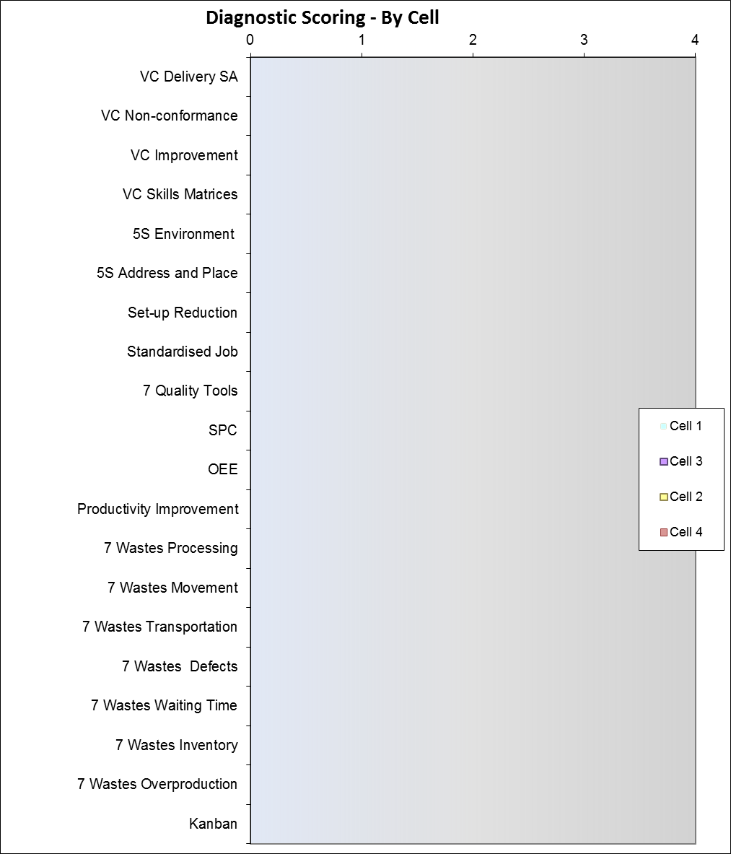

Figure - Graph of Diagnostic Scores by Cell

## Graph of Diagnostic Scores (Average vs. Target)

The graph below shows the average score achieved across all of the cells assessed against the 20 Diagnostics. The targets entered at this stage are suggested by the Lead Assessor and should be changed depending on your organisations priorities.

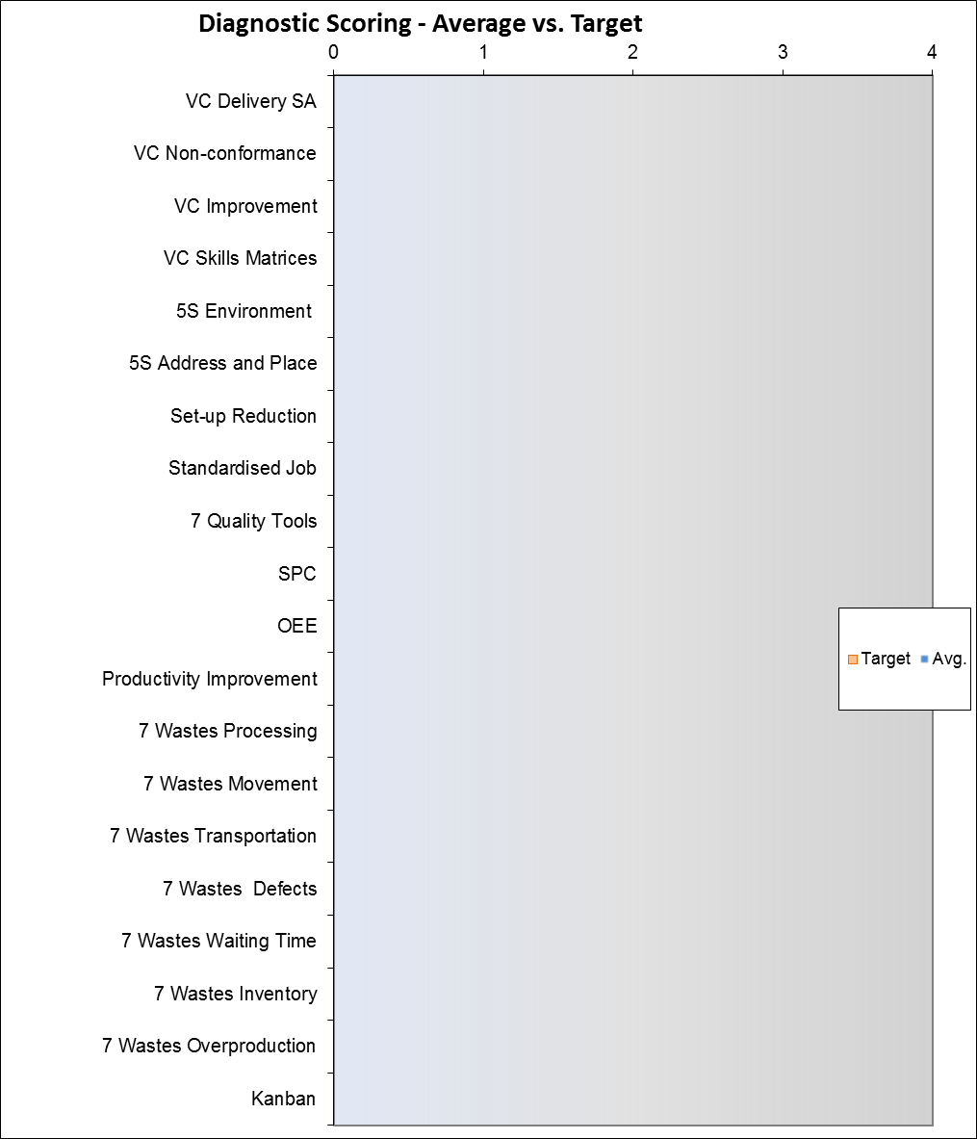

Figure - Graph of Diagnostic Scores Average vs. Target

# Section 2 – Management Commitment

#### What is Management Commitment?

Management Commitment is focused on understanding the managerial processes which ‘enable’ Lean within an organisation and what ‘results’ are being achieved as a consequence.

Managers may be ‘committed’ to a Lean philosophy but this assessment tests the integrity of that commitment and its maturity by addressing:-

* the structure or soundness of the approach
* how well it is integrated in the business over time
* its deployment across all areas
* how the approach and deployment are reviewed for effectiveness
* what results are being achieved to demonstrate that effectiveness

This ensures that Lean implementation is embedded and forms part of the organisation’s Continuous Sustainable Improvement Plan (CSIP).

## Management Commitment Enablers

### Approach



#### Strengths

#### Opportunities

#### Comments

### Deployment



#### Strengths

#### Opportunities

#### Comments

### Assessment and Refinement



#### Strengths

#### Opportunities

#### Comments

## Management Commitment Results

### Relevance and Usability



#### Strengths

#### Opportunities

#### Comments

### Performance



#### Strengths

#### Opportunities

#### Comments

# Management Commitment Scoring Summary



Figure - Graph of Management Commitment Scoring

# Overall Score

The overall Manufacturing Excellence score your organisation has achieved in this assessment is:-

|  |
| --- |
| **SC21 Man Ex Score** |
| 0 |

#### Weightings

The score above is made up of the overall average from the Diagnostic cell assessments and the scoring from the Management Commitment assessment weighted as follows:

* Diagnostic scoring **= 35%** of the overall score.
* Management Commitment scoring **= 65%** of the overall score.

This weighting recognises that lean and continuous improvement can only be successfully implemented in any organisation with the full backing and drive of its leadership team and key personnel through effective systems and processes.

#### Benchmarking

Below is a graph showing the current profile of benchmarking scoring captured through the life of the SC21 programme, this gives an indication of how you have scored in relation to the national averages on the programme.



#### Target Score

The score below is based on provisional estimates of the scoring your organisation should be able to achieve in your next assessment (2-3 years’ time) given reasonable effort is applied to the implementation of the Opportunities for Improvement highlighted in this report. These targets should be adjusted by you according to your organisations priorities and intentions; this can be done in the attached Excel workbook (Appendix 1).

|  |
| --- |
| **Potential Man Ex Score** (Score if all targets achieved) |
| 0 |

#### Thanks

The Assessment Team would like to extend their thanks to all involved with the assessment process for your efforts, openness and hospitality.

Any questions or concerns regarding the scoring or anything contained within this report please contact the Lead Assessor named within.

# Appendices

#### Appendix 1 – Scoring Workbook

The embedded excel workbook below contains the scoring and tables used to populate and update the various fields throughout this report document, it may also be used as a summary of the assessment scoring and to populate other documents such as feedback presentations and SC21 award submissions if required:-



Figure – Scoring Data

**Guidance to report writer** – To update the scoring in this report, open the embedded excel file (above) and copy the relevant tables and graphs into this word document. Sections to extract from the excel workbook include: Diagnostic tables (1-4 depending on number of cells assessed), diagnostic progress bars (against each of the 20 diagnostics), diagnostic scoring summary with graphs, Management commitment results tables, Management commitment scoring summary with graph and overall scores.