Document ref. | RxP04
Version | 1a
Date | June 2019

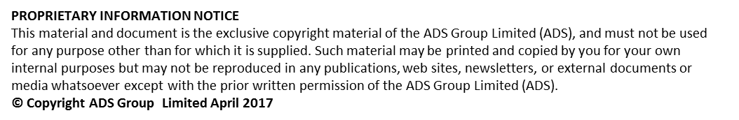

Document History
Document Location | SC21 Project Office

Version History

Version date | Date of previous version | Version | Author(s) | Summary of Changes | Approved by
Jan 13 | Nil | 1 | Unknown | RMM Facilitators Guidance Note Issue 1 jan 2013 | Unknown
June 19 | Jan 13 | 1a | David Singleton | Update – Contents/Format/Doc Name

Scope of Applicability
SC21  Lite | SC21  OE | SC21  C+G
Y | Y | N

Associated documents to be referred to
RxP04 - RMM Facilitators Guidance Note Issue 1 Jan 2013
RxP05 - RMM User Guide Issue 1 Jan 2013

Relationship Management Review - Deployment Guide
1 Introduction
Relationship management is a systematic approach for developing and managing key partnerships. It focuses on joint growth and value creation, is based on trust, open communication, empathy and a win_win orientation.
Organisations, who want to drive business results through the development of a collaborative working benefit from deploying relationship lean tools, techniques and philosophies.
The SC21 supply chain relationship code of practice establishes the philosophies and guidelines by which organisations can work together to achieve sustainable benefit. Relationship lean tools such as the relationship management review (RMR) toolset enables organisations to benchmark themselves against the principals defined within the code of practice whilst striving towards common improvement objectives, and an improved relationship desired future state.
2 Benefits
Typical benefits to deploying the RMR too set:
- Improves understanding of customer requirements and expectations
- Encourages open communication, trust, transparency and co-operation
- Highlights joint improvement initiatives and define the improvement path
- Supports joint issue resolution, reduce risk & improve performance (QCD)
3 Considerations and prerequisites to deployment
The RMR process is based on the principle of “Plan, Do, Review”, it’s easy to understand, deploy and is therefore applicable to all stages of relationship development or management and at all stages of the project/product lifecycle.
Considerations to the scope and scale of activities undertaken will be determined by factors such as maturity and complexity of existing relationships, risk implications, levels of stakeholder engagement, overall strategic direction, relationship classification and priority.
Low ( Risk ) High
Strategic
High value Business Critical
Collaborative thinking
Growth potential

Complex
Developing joint value
Multiple interfaces
Large projects

Developing
New relationship
Leading edge technology
Expert to expert engagement

Developing potential
Stable
Established programmes
Low variation
Optimal engagement

*Strategic and more complex relationships may require facilitation from an independent and/or approved SC21 facilitator. *Low risk and developing relationships can be facilitated by local/deploying entities that are independent from the relationship.
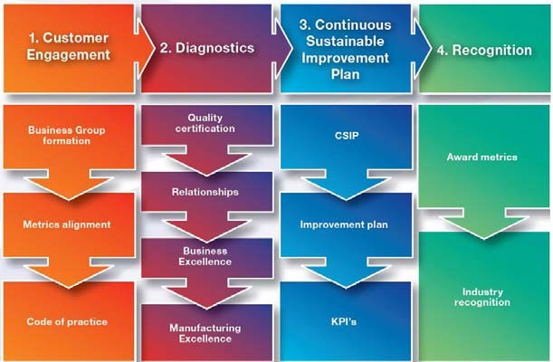
The SC21 relationship excellence framework
can assist organisations in defining their
relationship classifications and priorities.

The RMR tool set is a key enabler to measure
manage and improve relationship in order to
meet the overall business objectives.

One of the critical success factors when undertaking a relationship management review is obtaining senior or executive sponsorship. This will be someone whom has a vested interest in the success of the process, authority to remove obstacles and encourage openness whilst driving accountability through action and improvement.
- Process Overview
Improvement Plan
Workshop
Analysis
Planning

Planning
In order to achieve a successful relationship management review workshop, it’s important to have completed the necessary preparation during the planning phase.
Completion of the planning checklist will help facilitators to manage the key activities leading up to the workshop:
- Agreed scope of activity for example i.e. specific sites or business units
- Agreed stakeholder map including sponsorship
- Awareness presentation
- Issued agenda and timing plan
- Issued question set with analysis expectations

Analysis
Once the questions have been issued and returned to the facilitator, the data can be compiled using the RMR-Questionnaire Analysis Workbook and analysed. It’s important to identify the key differences in the relationship and scoring and identify any outliers that may skew the results.
Further discussion may be required to clarify points and scores and this may help to draw out some of the issues affecting the relationship.
The RMR analysis workbook automatically generates a chart illustrating participants who have identified the relationship as “Failing / Disengages” (Score - 0) or “Reactive” (Score - 1) against any of the criteria measured.
Three key points to remember:
- Establishing a consensus can be difficult but differences in perception will provide material for debate.
- Encourage reinforcement of poor perceptions with comments.
- Don’t get hung up on the numbers game, focus on the relationship state.
Workshop
This activity can be conducted as part of a joint review such as a strategic/tactical business review or run as a separate workshop. Enough time must be allocated to achieve the desired outcome and deliver the improvement plan. This may vary due to the complexity and scale of the relationship. Set the scene with senior sponsorship endorsement especially in more complex relationships.
Use the agenda to control timings and focus delivery. Work towards an agreed consensus “As Is” current state as this will baseline the relationships starting position and will enable future comparisons to be made. Deep dive into areas highlighted during the analysis phase to stimulate discussion and capture opportunities as they arise. Agree the future “To be” target sate and nex review time line.
Three key points to remember:
- Use the comments from the analysis workbook to facilitate debate
- Use gaps in the perception to stimulate discussion
- Capture opportunities as outputs to the discussions
Improvement
Review opportunities as a conclusion to the workshop and explore improvement actions. Allocate ownership and a desired completion time frame. This forms the basis of the improvement plan or CSIP. Actions should focus on overcoming the perception gaps and addressing those issues that are perceived to be holding‐back the relationship. Equally, there may be issues that the key stakeholders are keen to promote in the relationship and actions should support those.
When prioritising issues/actions it may be useful to consider how easy or difficult the improvement action will be to implement against the level of benefit anticipated.
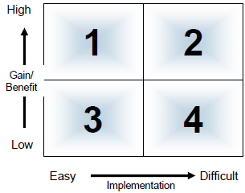
Actions that are easy to implement and will deliver high benefit should be treated as priority; these quick wins can also be useful to demonstrate the value of the process and to ensure support for further action.
Actions that may be more difficult to implement but will deliver substantial benefit will require strong sponsorship and should be regularly reviewed as part of the Relationship Management Plan.
Assets
- Code of practice - link
- Planning checklist (TO be defined*******)
- Workshop Checklist (To be defined)
- Standard Agenda (Needs looking at also)
- RMR – Questionnaire
- RMR – Analysis workbook Improvement plan template

