

|  |
| --- |
| **SC21 Programme** |
| Business Excellence Assessment Process Guide |
| **The EFQM Model 2020**  **Document Reference – BxP01**  **Version – 2**  **Date – March 2020**  Prepared by - The SC21 Performance, Development and Quality (PDQ) Special Interest Group (SIG) |

# Document History

|  |  |  |  |  |
| --- | --- | --- | --- | --- |
| Date | Version | Author(s) | Summary of Changes | Approved by |
| Dec 2013 | 1 | Peter Laurie | 2013 Issue. (This and any previous documents not version controlled) | PDQ SIG |
| Mar 2019 | 2 | Ross Harrison | Update to align to The EFQM Model 2020. Formatting, Document structure, Practitioner training process, additional supporting documents, diagnostic content, increased detail & information to drive standardisation in approach | PDQ SIG |

# Scope of Applicability

|  |  |  |
| --- | --- | --- |
| SC21 Lite | SC21 OE | SC21 C+G |
| Y | **Y** | **N** |

# Associated Documents

|  |  |
| --- | --- |
| Document Title | Document No. |
| Bus Ex Self-Assessment Workbook | BxT01 |
| Bus Ex Self-Assessment Compilation Workbook | BxT02 |
| Bus Ex Assessment Workbook | BxT03 |
| Bus Ex Scoring Workbook | BxT04 |
| Bus Ex Assessment Report Template | BxT05 |
| Bus Ex Enabler & Results Mapping Template | BxT06 |

Contents

Document History 2

Scope of Applicability 2

Associated Documents 2

SC21 Business Excellence Overview 3

Acknowledgement 3

The EFQM Model - Introduction 3

Supporting Documentation 4

Launch meeting 5

Assessment Team & Practitioners 5

Assessment 6

Assessment Levels 6

Assessment Methodology 6

Feedback 12

Benchmarking 13

Checklist - Preparing for a Manufacturing Excellence Assessment 14

Business Excellence Self-Assessment (SC21 Lite) 14

# SC21 Business Excellence Overview

## Acknowledgement

The methodology used in the SC21 Business Excellence Assessment is based on The EFQM Model. ADS Group acknowledges the EFQM copyright and is grateful for the permission granted to use the EFQM Model within the SC21 Business Excellence Process documentation.

## The EFQM Model - Introduction

The EFQM Model is a globally recognised framework that supports organisations in managing change and improving performance. The EFQM Model is strategic in nature, focussed on operational performance, results orientated, and helps to test the alignment of an organisation’s ambitions for the future, against its current ways of working and its responses to challenges.

The EFQM Model structure is based on the simple but powerful logic of asking three questions:

* **“Why”** does this organisation exist? What Purpose does it fulfil? Why this particular Strategy? **(Direction)**
* **“How”** does it intend to deliver on its Purpose and its Strategy? **(Execution)**
* **“What”** has it actually achieved to date? “What” does it intend to achieve tomorrow? **(Results).**

The Central rationale of the EFQM Model is the connection between the Purpose and Strategy of an organisation and how that is used to help it Create Sustainable Value for its Stakeholders and deliver outstanding Results.

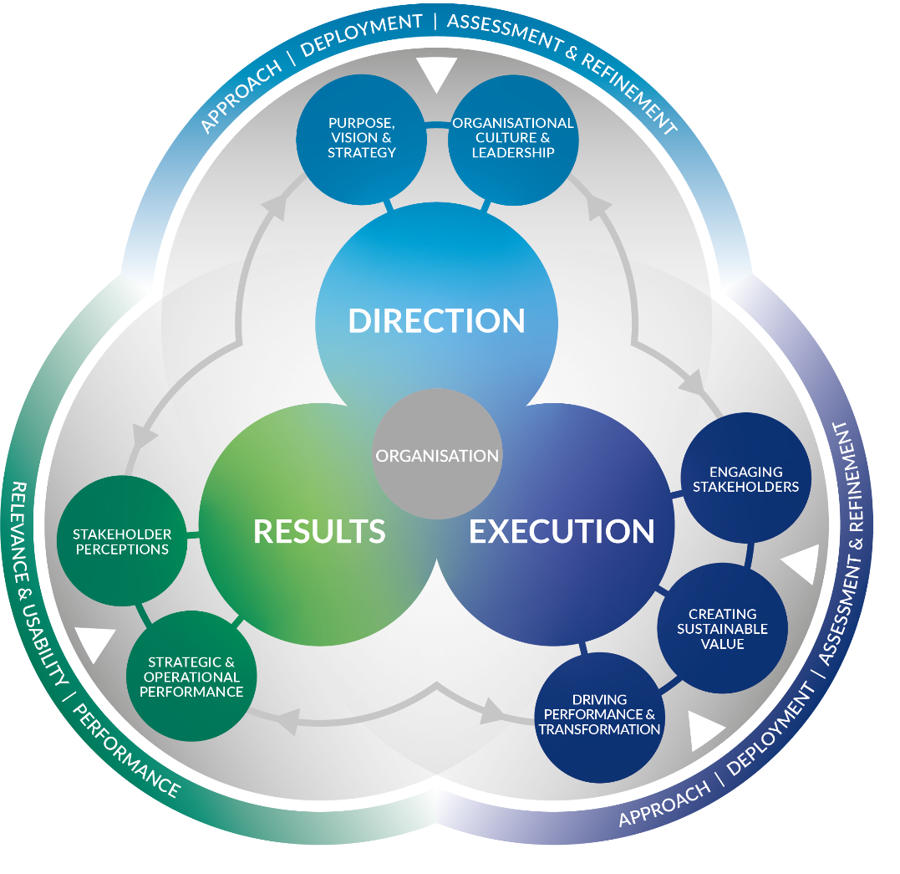

Figure 1: The EFQM Model

## Supporting Documentation

The following documents are required to undertake this process, they are designed to simplify and standardise the application of this assessment methodology for the purposes of this assessment process.

|  |  |  |
| --- | --- | --- |
| Document Title | Document No. | Purpose |
| Self-Assessment Workbook | BxT01 | Used for the purposes of internal self-assessment, in preparation for the practitioner facilitated assessment and for “SC21 Lite” |
| Self-Assessment Compilation Workbook | BxT02 | Used to consolidate responses from multiple stakeholders completing the **“Self-Assessment Workbook”** (above) |
| Assessment Workbook | BxT03 | Practitioner assessment document and guidance to be used to conduct the on site assessment |
| Scoring Workbook | BxT04 | Used to calculate the assessment scores and generate visual elements, charts and graphs for the purposes of initial feedback presentation, assessment reporting (Feedback Template) and transfer to SC21 submission template |
| Assessment Report Template | BxT05 | Used by Practitioners to generate the assessment report to feed back to the organisation. SC21 standard template. |
| Enabler & Results Mapping Template | BxT06 | Used to collect data and evidence in preparation for the practitioner facilitated assessment (Silver & Gold Level) |

The supporting documentation listed above aligns directly with the core 3 stages of the assessment process as shown below:

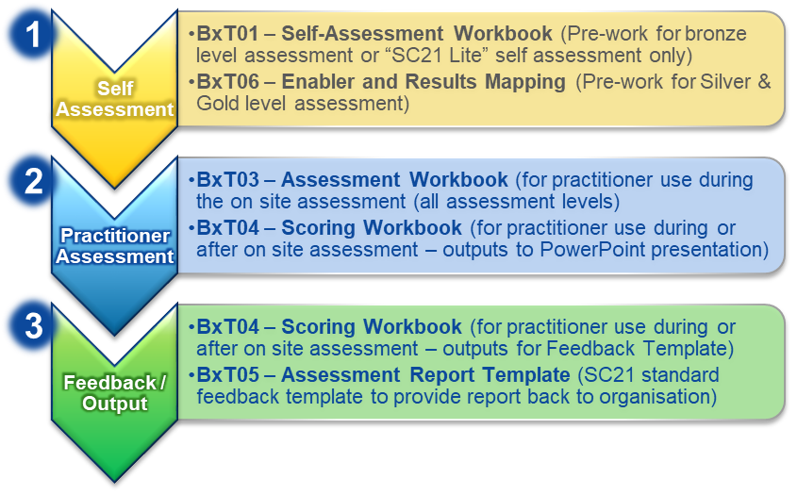

Figure 2: Process & Supporting Documentation Alignment

# Launch meeting

The Assessment Team Leader will give a presentation to the organisation’s management team.

The presentation should cover:-

* An overview of The EFQM Model and the assessment templates used in SC21.
* Explanation of the scoring with particular reference to the principles and practices of RADAR scoring.
* Agreement on the assessment template to be used.
* Suggestions for the number of people to be involved for each assessment approach.
* Explanation of the preparation required from the organisation prior to the on site assessment.
* Agree a date and duration for the on site assessment.
* Delivery of the Feedback report of Strengths and Opportunities for Improvement and the SC21 Business Excellence score.
* The Organisation must be given or obtain a copy of **The EFQM Model brochure: ISBN: 978-90-5236-845-0**

# Assessment Team & Practitioners

For the purposes of conducting a Business Excellence Assessment recognised by the SC21 Programme, Practitioners must be fully trained and verified by the SC21 PDQ SIG, in accordance with the **SC21 Practitioner Requirements** Document. The structure of the practitioner training process is shown below:-

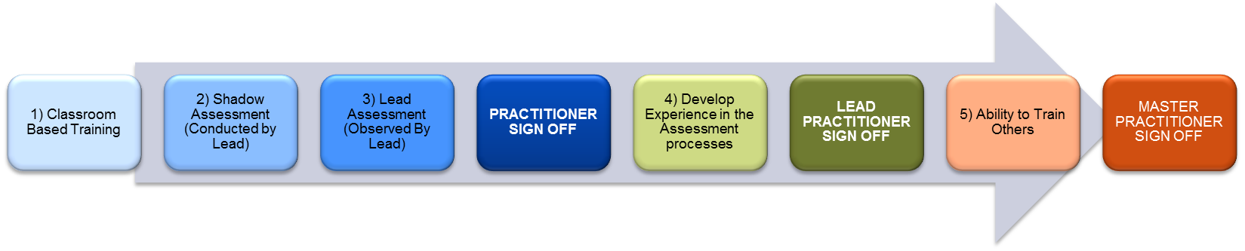

The minimum requirement is that a recognised **Lead Practitioner** forms part of the assessment team, under their guidance unqualified Practitioners may support the assessment, although they should have undertaken classroom based training modules before doing so. The current list of approved Practitioners can be found on the following SC21 website page: <https://www.sc21.org.uk/sc21-knowledge-providers/how-to-be-a-sc21-practitioner/>

It is possible to use this assessment toolset internally as part of the SC21 Lite process, however if the assessment is not conducted by a Lead Practitioner the assessment score is not admissible for SC21 recognition. *(Note: SC21 Lite is a self-assessment approach to SC21 encouraging the use of the assessment toolsets for self-driven improvement activity – see the SC21 website for more information)*

### Assessment Team Structure

The number of Practitioners involved in an assessment will depend on the size of the organisation and the recognition level to be achieved. It is recommended that a consensus approach is taken when conducting all assessments (a minimum of 2 Practitioners); this is to ensure the assessment scoring is conducted in a fair and balanced manner and the opportunity for individual bias is minimised. Where this is not practical however, and for larger, more mature organisations the minimum numbers mandated by the PDQ SIG are highlighted below:

|  |  |  |  |
| --- | --- | --- | --- |
| Company Size | Bronze | Silver | Gold |
| Small <50 employees | 1 | 1 | 2 |
| Medium <250 employees | 1 | 2 | 3 |
| Large >250 employees | 2 | 3 | 3 |

# Assessment

## Assessment Levels

There are 2 levels of assessment used by the SC21 programme based on The EFQM Model “Determining Excellence Assessment”. The levels and their application are as follows:

1. Bronze Level Assessment – this is a basic version of the assessment using a simplified “ABCDE” scoring model. This assessment level is designed to be used as an entry level for organisations starting their journey of improvement with SC21 or with The EFQM Model. This level is also designed to be used as a self-assessment, both in preparation for the practitioner facilitated assessment and for the purposes of “SC21 Lite”. It may also be appropriate for organisations, already engaged in SC21, who do not expect to score more than 350. This format is acceptable for SC21 Recognition at Bronze level only.
2. Silver & Gold Level Assessment – this is the same questionnaire model as the Bronze level assessment, however the scoring is conducted at a more detailed level and uses the EFQM RADAR® scoring approach. An organisation which has previously completed a Bronze level assessment would be encouraged to undertake an assessment using the Silver & Gold level approach to progress their journey to Excellence. It is also important to note that the Silver & Gold Level Assessment is a requirement for SC21 award submissions above Bronze award.

*Note: It is expected that the Practitioner will advise the organisation involved on which approach should be used for assessment. This will be dependent on maturity against the Excellence Model, positioning against SC21 Recognition levels or the organisation’s requirements for improvement or benchmarking.*

## Assessment Methodology



The assessment process follows the basic high level process steps above, the differences between how the stages of the assessment are conducted are described below:

### Self-Assessment

#### Bronze (Entry) Level

A self-assessment questionnaire using **BxT01 - Bus Ex Self-Assessment Workbook** (based on the EFQM Determining Excellence Questionnaire) is completed by a selected range of stakeholders within the organisation and shared with the Lead Practitioner prior to the on site assessment. Scoring is based on levels A, B, C, D or E allowing users who are not familiar with RADAR® scoring methodology to conduct a basic assessment.

The Self-Assessment Questionnaire consists of 35 questions which may not give a complete picture of an organisation’s positioning against the Excellence Model but does provide a useful starting point and will help to identify opportunities for Improvement to be captured as activities in a Continuous Sustainable Improvement Plan (CSIP).

Organisations should describe the approaches and results for each question, there is a ‘Notes’ section in the Workbook for this purpose.

Full instructions for the use of the Self-Assessment Workbook are contained within the Workbook itself. Scoring is automated within the workbook but is described later in this process guide for clarity.

The questionnaire should be completed by a range of stakeholders to give a holistic view of the organisation and to capture different perspectives. These may include representatives from different functions, different hierarchical positions etc. but should cover at least the senior management team representatives. The questionnaires should be completed individually based on the person’s perspective as opposed to agreeing a consensus position. The responses should be returned to the practitioner prior to the on site assessment.

The individual questionnaire responses should be analysed and consolidated in the workbook **BxT02 - Self-Assessment Compilation Workbook** this workbook will be used to facilitate and provide inputs to the discussion during the on-site assessment. Typically the Lead Practitioner would consolidate the individual responses and perform the analysis, however if the organisation wish to do this themselves and have their own internal consensus discussion prior to the assessment this should be encouraged.

#### Silver & Gold Level

A self-assessment template using **BxT06 - Bus Ex Enabler & Results Mapping** (based on the EFQM Determining Excellence Questionnaire) is completed by the organisation with inputs from a range of stakeholders as required. The gathered information is then shared with the Lead Practitioner prior to the on site assessment. There is no requirement to score the self-assessment, it is intended as evidence collection only at this stage.

The Enabler & Results Mapping template is based on the same 35 questions as the Bronze level assessment. This may not give a complete picture of an organisation’s positioning against the Excellence Model, but does provide a useful set of information as input to the assessment and will help to identify opportunities for Improvement to be captured as activities in a Continuous Sustainable Improvement Plan (CSIP).

The Silver & Gold assessment level should be used by organisations requiring a more detailed assessment against the EFQM Excellence Model for benchmarking or to drive improvement. It is also a requirement for any organisations submitting for SC21 Silver or Gold award.

The template should be completed with inputs from the appropriate senior stakeholders responsible for the relevant subject matter. It will require input from the senior management team representatives as a minimum but will likely require support from Subject Matter Experts from across the business. It is recommended that the 35 questions are broken down and allocated to appropriate individuals to complete the necessary response managing input from others where appropriate (certain questions will require cross functional input). Inputs will need to be co-ordinated by a single point of contact on behalf of the organisation.

Enabler & Results mapping requires that the template be completed by adding detail of the ***Approach***, ***Deployment****,* ***Assessment & Refinement*** and ***Results linkage*** against each of the “Enabler” questions, and ***Relevance & Usability*** and ***Performance*** for each of the “Results” questions. Further details and guidance are provided in the template itself.

The completed template should be returned to the Lead Practitioner prior to the on site assessment. The template also provides a useful record of the organisations maturity against the EFQM Model for their own internal benefit.

SC21 recommends that once an organisation achieves a level of maturity against the EFQM Model (Silver and Gold Level Scores) they seek to undertake a **full EFQM Assessment** and achieve international recognition from EFQM directly. An assessment conducted through EFQM will be fully recognised by SC21 and acceptable as part of an award submission. The full assessment will also provide a more in depth assessment and highlight further opportunities for improvement.

### Practitioner Led Assessment Workshop

The Business Excellence Assessment Workshop is conducted by interview with a broad representation of an organisations senior management team, ideally the Board of Directors / Senior Management Team will be involved.

At the start of the Assessment, the process to be followed and the objectives should be explained. The Senior Management representatives should be given the opportunity to ask any related questions at any point during the process.

The depth of questioning should be such that sufficient non-anecdotal evidence is collated to gain an understanding of the current situation. Using the information received (verbal/documented), notes should be taken by the Practitioner(s). These notes will assist in determining the score and defining strengths and Opportunities for Improvement.

The time taken to complete a Business Excellence Assessment Workshop will be dependent on a number of factors including the size and complexity of the organisation, the level of preparation work conducted etc. however a basic assessment will take at least a full day.

The document **Bus Ex Assessment Workbook BxT03** is available for practitioners use taking notes though the assessment.

### Assessment scoring

Scoring should be conducted during or following the assessment process using the **Bus Ex Scoring Workbook BxT04.** Where there are multiple Practitioners conducting the interview, scoring should be discussed following the assessment to achieve consensus between practitioners wherever possible; however, the Lead Practitioner should have the final say. Scoring for both Bronze Level and Silver & Gold Level are contained within the same workbook however the scoring approach itself will differ as described below:

#### Bronze Level Scoring

Bronze level scoring follows a simplified A, B, C, D, E scoring methodology as outlined below:

|  |  |  |  |  |  |
| --- | --- | --- | --- | --- | --- |
|  | E | D | C | B | A |
| Description (Enablers & Results) | Inability to achieve | Limited ability to achieve | Ability to achieve | Comprehensive ability to achieve | Outstanding ability to achieve |
| % Score | 0 | 10 | 25 | 50 | 75 |

It was found to be necessary to use a reduced scoring system for the self-assessment (maximum score achievable 750 or 75%) in order to align to scores achieved from a full practitioner led assessment using the RADAR® scoring logic.

Further details / guidance on this scoring methodology are contained within the Self-Assessment Workbook.

#### Silver Level Scoring - The EFQM RADAR Model

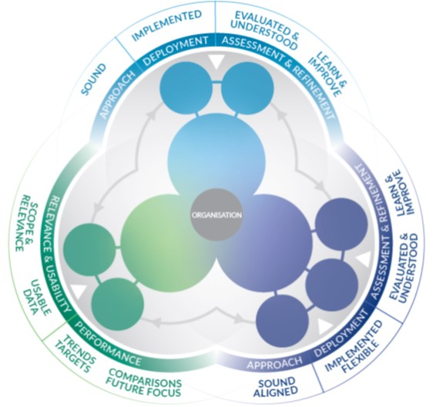

Figure 3: EFQM RADAR Model 2020

Silver scoring is based on the EFQM RADAR® scoring methodology, at its highest level, the RADAR logic states that an organisation should:

* Determine the **Results** it is aiming to achieve as part of its strategy
* Have in place a number of **Approaches** that will deliver the required results, both now and in the future
* **Deploy** these approaches appropriately
* **Assess and Refine** the deployed approaches to learn and improve.

To help deliver a more robust analysis, the RADAR elements are broken down into a number of Attributes and with each Attribute there is an associated description that expands upon what is meant and what the organisation should be able to clearly demonstrate. The following sections describe the attributes associated with each section of the EFQM Model.

##### Direction

For the Direction criterion: 1 (Purpose, Vision & Strategy) and 2 (Organisational Culture & Leadership), RADAR® scoring will be applied against Approach (Sound only), Deployment (Implemented only) and Assessment & Refinement (Evaluated & understood and Learn & Improve). Scores (0-100) will be recorded for Approach, Deployment and Assessment & Refinement individually in the scoring template. Guidance from the EFQM Model in scoring the Direction criteria is shown below:

|  |  |  |
| --- | --- | --- |
| Elements | Attributes | Description |
| Approaches | Sound | The approaches have a clear rationale, aim to fulfil and respond to Key Stakeholder needs, are described appropriately and are designed to be fit for the future. |
|  | *Aligned* | *N.B. Not applied to Direction* |
| Deployment | Implemented | The approaches are deployed in relevant areas in an effective and timely manner. |
|  | *Flexible* | *N.B. Not applied to Direction* |
| Assessment & Refinement | Evaluated & Understood | Feedback on the effectiveness & efficiency of the approaches and their deployment are collected, understood and shared. |
|  | Learn & Improve | Findings from emerging trends analysis, measurement, learning and benchmarking are used to inspire creativity and generate innovative solutions to improve performance in appropriate timescales. |

##### Execution

For the Execution criterion: 3 (Engaging Stakeholders), 4 (Creating Sustainable Value) and 5 (Driving Performance & Transformation), RADAR® scoring will be applied against Approach (Sound & Integrated), Deployment (Implemented & Structured) and Assessment & Refinement (Evaluated & understood and Learn & Improve). Scores (0-100) will be recorded for Approach, Deployment and Assessment & Refinement individually in the scoring template. Guidance from the EFQM Model in scoring the Direction criteria is shown below:

|  |  |  |
| --- | --- | --- |
| Elements | Attributes | Description |
| Approaches | Sound | The approaches have a clear rationale, aim to fulfil and respond to Key Stakeholder needs, are described appropriately and are designed to be fit for the future. |
|  | Aligned | The approaches support an organisation’s direction and are integrated with other relevant approaches. |
| Deployment | Implemented | The approaches are deployed in relevant areas in an effective and timely manner. |
|  | Flexible | The execution enables flexibility and adaptation. |
| Assessment & Refinement | Evaluated & Understood | Feedback on the effectiveness & efficiency of the approaches and their deployment are collected, understood and shared. |
|  | Learn & Improve | Findings from emerging trends analysis, measurement, learning and benchmarking are used to inspire creativity and generate innovative solutions to improve performance in appropriate timescales. |

##### Results

For the Results criterion: 6 (Stakeholder Perceptions) and 7 (Strategic & Operational Performance), RADAR® scoring will be applied against Relevance & Usability (Scope & Relevance, Useable Data) and Performance (Trends, Targets, Comparisons and Future Focus). Scores (0-100) will be recorded for Relevance & Usability and Performance individually in the scoring template. Guidance from the EFQM Model in scoring the Direction criteria is shown below:

|  |  |  |
| --- | --- | --- |
| Elements | Attributes | Description |
| Relevance & Usability | Scope & Relevance | A set of results that clearly link to the Purpose, Vision & Strategy of the organisation are identified. The selected set of Results is reviewed and improved overtime. |
|  | Useable Data | Results are timely, reliable, accurate and appropriately segmented to provide meaningful insights that support performance improvement and transformation |
| Performance | Trends | Positive trends or sustained outstanding performance over the strategic period/cycle |
|  | Targets | Relevant targets are set in line with the Strategy and are consistently achieved |
|  | Comparisons | Relevant external comparisons suitable to position own performance in line with the strategic direction are made and are favourable |
|  | Future Focus | Based on current cause & effect relationships, analysis of data sets, performance patterns & predictive measures, the organisation understands the drivers for outstanding performance in the future |

*Note: this is only a high level description of RADAR scoring, it is expected that Practitioners are trained in, and fully understand the RADAR scoring methodology before conducting a Business Excellence assessment.*

The weightings applied (points available) for each criterion of the EFQM Model are shown in the illustration below, the calculations are automated within the Scoring Workbook:



## Feedback

### Strengths & Opportunities

The key outputs of the Business Excellence Assessment are Strengths and Opportunities for Improvement.

* **Strengths** can be used as standards or examples of best/good practice and cascaded to or shared with other parts of the business.
* **Opportunities for Improvement** can be analysed for:
  + benefit to the business
  + actions planned or taken
  + incorporated in the CSIP

It may also be appropriate to note “Comments” for activities that have started recently or need further deployment.

### Initial Feedback Presentation

Where feasible, a feedback presentation should be compiled by the Assessment Team and presented to the organisation’s key stakeholders immediately following the assessment. Where it is not possible to provide the presentation in person, the presentation should still be created and sent to the organisation as a priority.

This presentation should contain as a minimum:

* High Level / Summary Strengths and Opportunities for Improvement covering all criterion stages within the Assessment.
* Assessment scoring (Graphical Outputs and an Overall Score).

The **Bus Ex Scoring Workbook BxT04** provides formatted outputs suitable for use in a presentation document. *Note: a standard template has not been created for this feedback to allow organisations to use their own company templates.*

### Feedback Report

In addition to the initial feedback presentation, a detailed assessment report will be prepared by the Assessment Team. The Lead Practitioner will collate the final version and send to the organisation. The **Bus Ex Assessment Report Template BxT05** should be used as the standard format for all assessment reports carried out under the SC21 programme.

The Feedback Report contains:-

* **Summary of Assessment Methodology and Objectives**
* **Feedback by Assessment Criterion:**
  + Detailed Strengths, Opportunities for Improvement, Comments and Scoring for each criterion
  + Scoring Summary with scoring tables
* **Overall Assessment Score**
* **Graph of Assessment Scoring**
* **Benchmarking**

*The Assessment Report should be sent to the company within three weeks of the workshop.*

## Benchmarking

The score and feedback can be used for future target setting and benchmarking (as below). *The latest update of the benchmarking data can be obtained from the SC21 Project Office.*



# Checklist - Preparing for a Manufacturing Excellence Assessment

Preparation by the Practitioner(s) is fundamental to deploying the Business Excellence assessment process successfully. It ensures that all the right people have an input and all the appropriate information is available and understood. Below are the suggested preparation steps: -

|  |  |  |
| --- | --- | --- |
| Step # | Description | Responsibility |
| 1 | The Organisation must be given or obtain a copy of The EFQM Model brochure: ISBN: 978-90-5236-845-0 | Lead Practitioner |
| 2 | SC21 and Business Excellence Awareness Presentations to the organisation & Launch Meeting | Lead Practitioner |
| 3 | Agreement on the assessment level to be used | Organisation and Practitioner(s) |
| 4 | Agree representatives of the organisation who will participate at both the self-assessment and on site assessment stages and agree outline agenda | Organisation and Practitioner(s) |
| 5 | Consider other SC21 stakeholders and key customers by referring to the SC21 National Status Report and agree their role in supporting the assessment where appropriate | Organisation and Practitioner(s) |
| 6 | Obtain relevant information relating to doing business with the organisation:   * Product / Service Supplied * Scope of business * Performance information (Delivery and Quality) * Issues / Concerns * Ongoing Improvement Activities | Practitioner(s) |
| 7 | Organisation to complete a self-assessment using the Self-Assessment Workbook or Enabler & Results Mapping Template as required and return to Lead Practitioner | Organisation |
| 8 | Compile and Analyse responses to the self-assessment using the Self-Assessment Compilation Workbook or review the Enabler & Results Mapping Document as required | Practitioner(s) |
| 9 | Prepare Manufacturing Excellence Material:   * SC21 Overview * SC21 Business Excellence Overview * Assessment Material including self-assessment if required * Initial Feedback Presentation template * Assessment Scoring Workbook * Assessment Report Template | Practitioner(s) |

## Business Excellence Self-Assessment (SC21 Lite)

For the purposes of SC21 Lite, the self-assessment workbook and the Self-Assessment Compilation Workbook should be used **(Bus Ex Self-Assessment Workbook BxT01 & Bus Ex Self-Assessment Compilation Workbook BxT02).** These workbooks are designed to allow users to score themselves against the assessment model, and contain a simplified A-E scoring approach as opposed to RADAR scoring as described earlier in this process guide.

The results and output from this self-assessment can be used for an organisation’s internal improvement purposes, however **cannot** be used to support an SC21 award submission.