

|  |
| --- |
| **Company Name** |
| SC21 Business Excellence Assessment Report |
| **Document Reference – BxT05**  **Version – 1**  **Issue Date – March 2020**  **Assessment Date: [Pick the date]**  Assessor Name(s) |

# Document History

|  |  |  |  |  |
| --- | --- | --- | --- | --- |
| Date | Version | Author(s) | Summary of Changes | Approved by |
| Mar 2020 | A | Ross Harrison | New Document to Standardise report writing | PDQ SIG |

# Scope of Applicability

|  |  |  |
| --- | --- | --- |
| SC21 Lite | SC21 OE | SC21 C+G |
| Y | **Y** | **N** |

# Associated Documents

|  |  |
| --- | --- |
| Document Title | Document No. |
| Bus Ex Assessment Process Guide | BxP01 |
| Bus Ex Self-Assessment Workbook | BxT01 |
| Bus Ex Self-Assessment Compilation Workbook | BxT02 |
| Bus Ex Assessment Workbook | BxT03 |
| Bus Ex Scoring Workbook | BxT04 |
| Bus Ex Enabler & Results Mapping Template | BxT06 |

# Contents

Document History 1

Scope of Applicability 1

Associated Documents 1

Contents 1

Introduction & Approach 2

SC21 Bronze Level Scoring 4

SC21 Silver & Gold Level Scoring 5

Deployment 6

Direction 7

Criterion 1 - Purpose, Vision & Strategy 7

Criterion 2 - Organisational Culture & Leadership 8

Execution 9

Criterion 3 - Engaging Stakeholders 9

Criterion 4 - Creating Sustainable Value 10

Criterion 5 - Driving Performance & Transformation 11

Results 12

Criterion 6 - Stakeholder Perceptions 12

Criterion 7 - Strategic & Operational Performance 13

Scoring Summary 14

Benchmarking 15

Target Scoring 15

Appendices 16

# Introduction & Approach

This Assessment Feedback Report summarises the findings of the SC21 Business Excellence Assessment which took place at the company facility in Click here to enter text..

This Business Excellence Assessment was conducted by Click here to enter text. (Lead Assessor) and Click here to enter text..

#### Assessment Scope and Structure (Bronze Level)

The organisation performed a self-assessment using the Self-Assessment Questionnaire which formed the basis of discussion during the assessment. The format for the assessment was interview and discussion with a group of personnel representing various functions of the organisation. The assessment was conducted using the EFQM Determining Excellence Model with reference to the full EFQM Business Excellence Model.

#### Assessment Scope and Structure (Silver & Gold Level)

The organisation prepared an enablers and results mapping document against the Determining Excellence Questionnaire which formed the basis of discussion during the assessment. Enabler and Results mapping presents detail of the ***Approach***, ***Deployment****,* ***Assessment & Refinement*** and ***Results linkage*** against each of the “Enabler” questions, and ***Relevance & Usability*** and ***Performance*** for each of the “Results” questions. The format for the assessment was interview and discussion with a group of personnel representing various functions of the organisation. The assessment was conducted using the EFQM Determining Excellence Model with reference to the full EFQM Business Excellence Model.

#### Assessment Context

This Report provides a general commentary on the organisation’s maturity against the Business Excellence Model and detailed commentary on Strengths and Opportunities for Improvement. The report also provides an overall score for the assessment as well as detailed scores for each of the questions throughout the report and a breakdown of scoring with graphs to help highlight key areas of strength and opportunity.

#### Assessment Approach

The EFQM Business Excellence Model used as the assessment tool for this activity is shown below:-

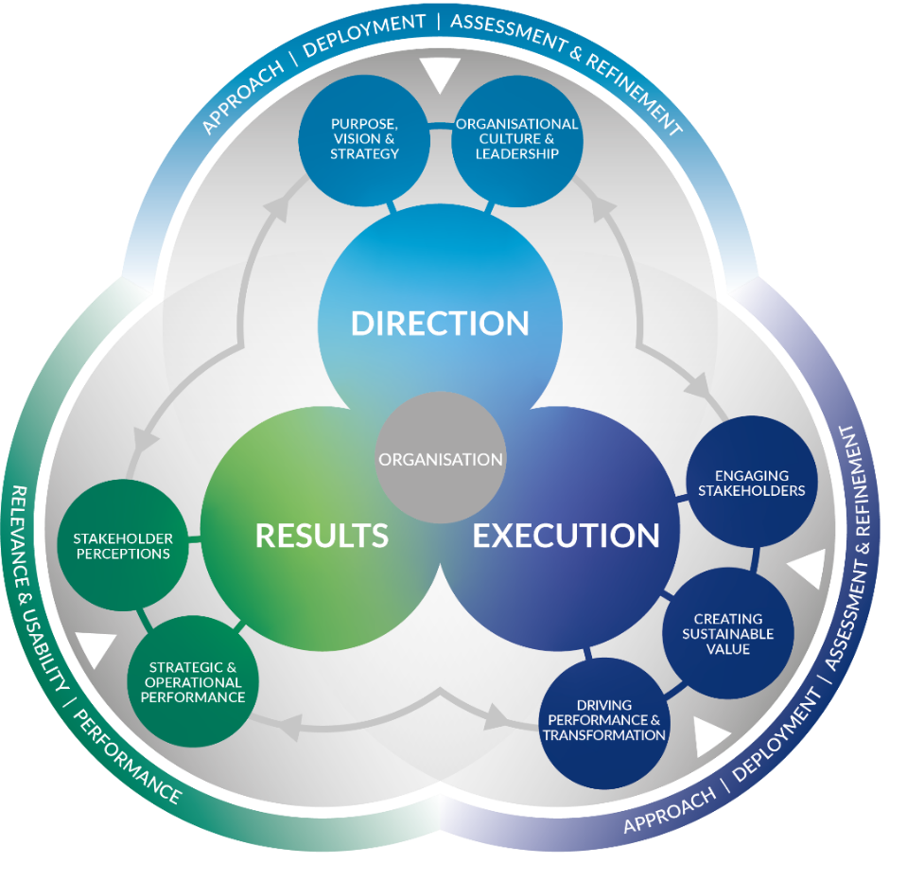

**Figure 1 –** The EFQM Model (2020)

## SC21 Bronze Level Scoring

Bronze level scoring follows a simplified A, B, C, D, E scoring methodology as outlined below:

|  |  |  |  |  |  |
| --- | --- | --- | --- | --- | --- |
|  | E | D | C | B | A |
| Description (Enablers & Results) | Inability to achieve | Limited ability to achieve | Ability to achieve | Comprehensive ability to achieve | Outstanding ability to achieve |
| % Score | 0 | 10 | 25 | 50 | 75 |

It was found to be necessary to use a reduced scoring system for the self-assessment (maximum score achievable 750 or 75%) in order to align to scores achieved from a full practitioner led assessment using the RADAR® scoring logic.

## SC21 Silver & Gold Level Scoring

For SC21 Silver & Gold level, the assessment has been conducted against the Determining Excellence Model questions however the scoring used is the RADAR® logic (illustrated below). Scoring for this assessment has been carried out by SC21 qualified practitioner(s). For more information on “RADAR” Scoring please ask your practitioner.

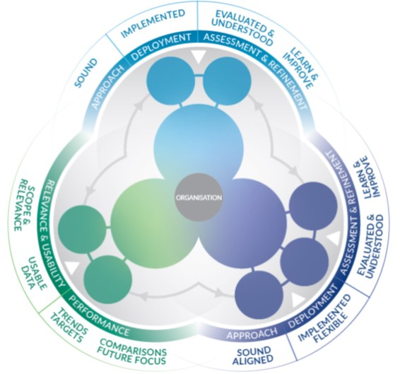

Figure 2: EFQM RADAR Model 2020

Silver scoring is based on the EFQM RADAR® scoring methodology, at its highest level, the RADAR logic states that an organisation should:

* Determine the **Results** it is aiming to achieve as part of its strategy
* Have in place a number of **Approaches** that will deliver the required results, both now and in the future
* **Deploy** these approaches appropriately
* **Assess and Refine** the deployed approaches to learn and improve.

## Deployment

The deployment of the activities identified this report will need to be managed through a dedicated plan, the Continuous Sustainable Improvement Plan (CSIP). It is important that this demanding activity is achieved in a measured and structured way. Focus on the areas of greatest benefit will be needed to ensure time and resource is used as effectively as possible.

#### Prioritisation Matrix

It is recommended that the Opportunities contained in this report be reviewed against a ‘Prioritisation Matrix’, and therefore ranked before being included in the Continuous Sustainable Improvement Plan (CSIP). It is important to remember that the CSIP needs to be balanced, selecting all the “easy” activities may result in a plan that is easy to implement and achieve but it may not result in much benefit to the organisation overall. Likewise selecting all the difficult / long term activities could possibly result in a plan that stagnates and de-motivates those involved through lack of tangible progress and benefits.

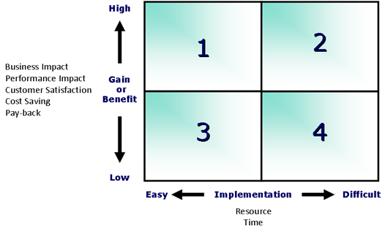

Figure 3: CSIP Prioritisation 4 Box Model

# 

# Direction

## Criterion 1 - Purpose, Vision & Strategy

An outstanding organisation is defined by a Purpose that inspires, a Vision that is aspirational and a Strategy that delivers.

The **Purpose** of the organisation:

* Explains why its work is important
* Sets the scene for it to create and deliver sustained value for its stakeholders
* Provides a framework in which it takes responsibility for its contribution to, and impact on, the ecosystem in which it operates.

The **Vision** of the organisation:

* Describes what the organisation is attempting to achieve in the long-term
* Is intended to serve as a clear guide for choosing current and future courses of action
* Provides, along with the organisation’s Purpose, the basis for setting the Strategy.

The **Strategy** of the organisation:

* Describes how it intends to fulfil its Purpose
* Details its plans to achieve the strategic priorities and move closer to its Vision.



*Strengths*

*Opportunities*

*Comments*

## Criterion 2 - Organisational Culture & Leadership

Organisational Culture is the specific collection of values & norms that are shared by people and groups within an organisation that influence, over time, the way they behave with each other and with Key Stakeholders outside the organisation.

Organisational leadership relates to the organisation as a whole rather than any individual or team that provides direction from the top. It is about the organisation acting as a leader within its ecosystem, recognised by others as a role model, rather than from the traditional perspective of a top team managing the organisation.

In an outstanding organisation, leadership is positioned as an activity not a role and leadership behaviours are evident across all levels and parts of the organisation. This role model leadership behaviour inspires others, reinforces, and when necessary, adapts the values and norms, helping to steer Organisational Culture.

An organisation that aspires to be recognised as outstanding, a leader within its ecosystem, achieves success through a focus on the following activities.



*Strengths*

*Opportunities*

*Comments*

# Execution

## Criterion 3 - Engaging Stakeholders

Having decided which Stakeholders are the most important to the organisation, i.e. its Key Stakeholders, and independent of the specific groups identified, it is highly likely that there is a degree of similarity in applying the following principles when engaging with Key Stakeholders.

An outstanding organisation:

* Identifies the specific types and categories within each of its Key Stakeholder Groups
* Uses its understanding of Key Stakeholders needs and expectations to achieve continued engagement
* Involves Key Stakeholders in deploying its Strategy and Creating Sustainable Value and recognises the contributions they make
* Builds, maintains and further develops the relationship with Key Stakeholders based on transparency, accountability, ethical behaviour and trust
* Works with its Key Stakeholders to develop a common understanding and focus on how, through co-development, it can contribute to, and draw inspiration from, the United Nations Sustainable Development Goals and Global Compact ambitions
* Actively gathers the perceptions of its Key Stakeholders rather than waiting for them to make contact.
* Evaluates its performance in relation to Key Stakeholders needs and decides on the appropriate actions to be taken to help secure its future, as perceived by these Key Stakeholders.



*Strengths*

*Opportunities*

*Comments*

## Criterion 4 - Creating Sustainable Value

An outstanding organisation recognises that Creating Sustainable Value is vital for its long-term success and financial strength.

The organisation’s clearly defined Purpose, enriched by the Strategy, defines for whom the organisation should be Creating Sustainable Value. In most cases, customers, segmented appropriately, are the target group for Creating Sustainable Value, although some organisations might also focus on selected Key Stakeholders within its Society or Business & Governing Stakeholder segments.

An outstanding organisation acknowledges that Key Stakeholder needs may change over time and that it is important to collect and analyse feedback to improve or change their products, services or solutions.

The different elements to Creating Sustainable Value are shown below in a step by sequence. It is recognised that the organisation’s plans for today and the future may well run in parallel or overlap at times, depending on the nature of the organisation’s business.



*Strengths*

*Opportunities*

*Comments*

## Criterion 5 - Driving Performance & Transformation

Now and in the future, an organisation needs to be able to meet the following two important requirements at the same time to become and remain successful.

On the one side, it needs to continue managing successfully the delivery of its current business operations. (“Driving Performance.”)

On the other side, there are constant changes inside and outside the organisation that need to be managed in parallel if it is to remain successful. (“Driving Transformation.”)

The combination of Driving Performance & Transformation confirms the necessity for the organisation to deliver for today while preparing for the future.

Major elements in enabling performance & transformation are innovation and technology, the ever-increasing importance of data, information & knowledge and the focussed use of critical assets and resources.



*Strengths*

*Opportunities*

*Comments*

# Results

## Criterion 6 - Stakeholder Perceptions

This criterion concentrates on results based on feedback from Key Stakeholders about their personal experiences of dealing with the organisation – their perceptions. These perceptions could relate to past as well as current Key Stakeholders and could be obtained from a number of sources, including surveys, focus groups, ratings, press or social media, external recognition, advocacy, structured review meetings, investor reports and compliments/complaints, including feedback compiled by customer relationship management teams.

In addition to the perceptions that a Key Stakeholder may have of an organisation based on personal experiences, perceptions may also be shaped by the environmental and social impact reputation of the Organisation. For instance, the degree to which the organisation is perceived by its Key Stakeholders as contributing successfully to one or more of the United Nations Sustainable Development Goals and Global Compact ambitions.

In practice, we find that an outstanding organisation:

* Knows how successful it is at executing its Strategy to meet the needs and expectations of its Key Stakeholders
* Uses its analysis of past and current performance to predict future performance
* Uses Key Stakeholder Perception Results to stay informed and influence its current Direction and the Execution of its Strategy.



*Strengths*

*Opportunities*

*Comments*

## Criterion 7 - Strategic & Operational Performance

This criterion concentrates on results linked to the organisation’s performance in terms of:

* The ability to fulfil its Purpose, deliver the Strategy and Create Sustainable Value
* Its fitness for the future.

These results are used by the organisation to monitor, understand and improve its overall performance and to forecast the impact this performance will have on both the perceptions of its Key Stakeholders as well as its future strategic ambitions.

In practice, we find that an outstanding organisation:

* Uses both financial and non-financial indicators to help it measure its strategic and operational performance
* Understands the linkages between Key Stakeholder perceptions and actual performance and is able to predict, with a high degree of certainty, how future performance will evolve
* Considers the current and future needs and expectations of its Key Stakeholders when deciding on the most appropriate performance indicators to match its strategic & operational objectives
* Understands the cause and effect relationships that impact on performance and uses the results achieved to stay informed and influence its current Direction & Execution
* Uses the results currently being achieved to forecast its future performance with an expected degree of certainty.



*Strengths*

*Opportunities*

*Comments*

# Scoring Summary

The table below shows the breakdown of scoring by criterion for the assessment conducted along with the overall assessment score. Both percentage and weighted scores are shown, the weighted scores demonstrate that both “Customer Results” and “Business Results” are weighted at 1.5X reflecting the importance of these criterion.



#### Scoring Graph

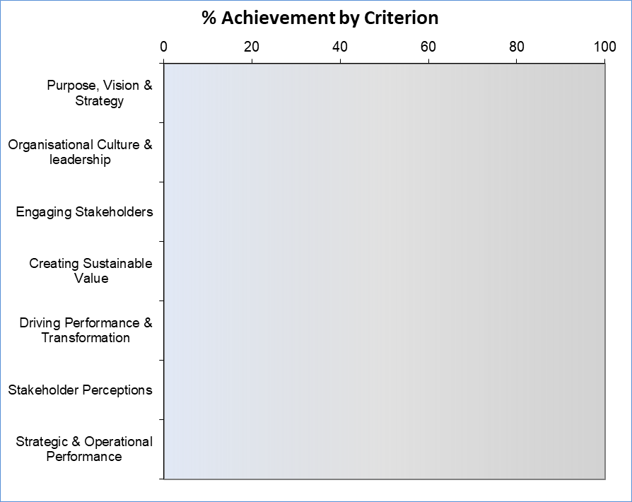

## Benchmarking

Below is a graph showing the current profile of benchmarking scoring captured through the life of the SC21 programme, this gives an indication of how you have scored in relation to the national averages on the programme.



## Target Scoring

The scoring below is based on provisional estimates of the scoring your organisation should be able to achieve in your next assessment (2-3 years’ time) given reasonable effort is applied to the implementation of the opportunities highlighted in this report. These targets should be adjusted by you according to your organisations priorities and intentions; this can be done in the attached Excel workbook (Appendix 1).



#### Thanks

The assessment team would like to extend their thanks to all involved with the assessment process for your efforts, openness and hospitality.

Any questions or concerns regarding the scoring or anything contained within this report please contact the Lead Assessor named within.

# Appendices

#### Appendix 1 – Scoring Workbook

The embedded excel workbook below contains the scoring and tables used to populate and update the various fields throughout this report document, it may also be used as a summary of the assessment scoring and to populate other documents such as feedback presentations and SC21 award submissions if required:-



**Figure 4 – Scoring Data**

**Guidance to report writer** – To update the scoring in this report, open the embedded excel file (above) and copy the relevant tables and graphs into this word document. Sections to extract from the excel workbook include: Criterion scoring tables (7 sections), Scoring Summary table and graph, Target Scoring table. All sections should be pasted as pictures into this document (Paste Special – Paste as Picture).