SC21 Business Excellence 2020
Enabler & Results Mapping Template
Date: [Pick the date]

Company Name

Contents
Contents 1
Instructions 2
Direction (Criterion 1-2) 2
Execution (Criterion 3-5) 2
Results (Criterion 6-7) 3
Assessment Approach 4
SC21 Scoring 4
Direction 5
Criterion 1 - Purpose, Vision & Strategy 5
Criterion 2 - Organisational Culture & Leadership 7
Execution 9
Criterion 3 - Engaging Stakeholders 9
Criterion 4 - Creating Sustainable Value 11
Criterion 5 - Driving Performance & Transformation 13
Results 15
Criterion 6 - Stakeholder Perceptions 15
Criterion 7 - Strategic & Operational Performance 17

Instructions
An Enabler Map and Results Section is required to capture the maturity of relevant approaches and to demonstrate that the management practices used by an organisation form a coherent system that is continually improved and delivers the intended strategy for the business.

Enabler mapping requires that this document be completed by adding detail of the Approach, Deployment, Assessment & Refinement and Results linkage against each of the “Direction” and “Execution” questions, and Relevance & Usability and Performance for each of the “Results” questions. The detail below explains what your SC21 Business Excellence Practitioners will be looking for when scoring the organisation. References to the full EFQM Model publication are also shown against each question.

Direction (Criterion 1-2)
Elements | Attributes | Description
Approaches | Sound | The approaches have a clear rationale, aim to fulfil and respond to Key Stakeholder needs, are described appropriately and are designed to be fit for the future.
 | Aligned | N.B. Not applied to Direction
Deployment | Implemented | The approaches are deployed in relevant areas in an effective and timely manner.
 | Flexible | N.B. Not applied to Direction
Assessment & Refinement | Evaluated & Understood | Feedback on the effectiveness & efficiency of the approaches and their deployment are collected, understood and shared.
 | Learn & Improve | Findings from emerging trends analysis, measurement, learning and benchmarking are used to inspire creativity and generate innovative solutions to improve performance in appropriate timescales.

Execution (Criterion 3-5)
Elements | Attributes | Description
Approaches | Sound | The approaches have a clear rationale, aim to fulfil and respond to Key Stakeholder needs, are described appropriately and are designed to be fit for the future.
 | Aligned | The approaches support an organisation’s direction and are integrated with other relevant approaches.
Deployment | Implemented | The approaches are deployed in relevant areas in an effective and timely manner.
 | Flexible | The execution enables flexibility and adaptation.
Assessment & Refinement | Evaluated & Understood | Feedback on the effectiveness & efficiency of the approaches and their deployment are collected, understood and shared.
 | Learn & Improve | Findings from emerging trends analysis, measurement, learning and benchmarking are used to inspire creativity and generate innovative solutions to improve performance in appropriate timescales.

Results (Criterion 6-7)
Elements | Attributes | Description
Relevance & Usability | Scope & Relevance | A set of results that clearly link to the Purpose, Vision & Strategy of the organisation are identified. The selected set of Results is reviewed and improved overtime.
 | Useable Data | Results are timely, reliable, accurate and appropriately segmented to provide meaningful insights that support performance improvement and transformation
Performance | Trends | Positive trends or sustained outstanding performance over the strategic period/cycle
 | Targets | Relevant targets are set in line with the Strategy and are consistently achieved
 | Comparisons | Relevant external comparisons suitable to position own performance in line with the strategic direction are made and are favourable
 | Future Focus | Based on current cause & effect relationships, analysis of data sets, performance patterns & predictive measures, the organisation understands the drivers for outstanding performance in the future

Assessment Approach
The EFQM Model used as the basis of the assessment tool for this activity is shown below:-
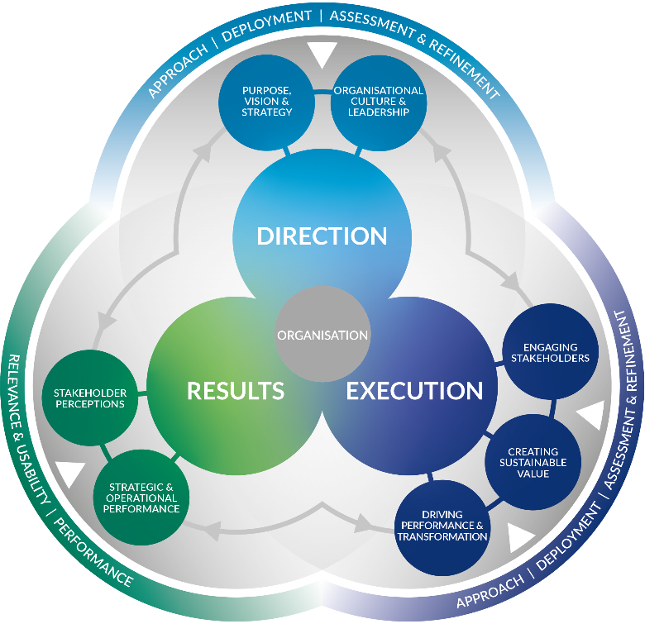
Figure 1 – The EFQM Model 2020

SC21 Scoring
As your organisation increases in maturity against the EFQM Model, the ‘Silver & Gold’ level assessment is conducted against the EFQM Determining Excellence Questionnaire however the scoring used is the RADAR® logic (illustrated below). Scoring for this assessment must be carried out by SC21 qualified practitioner(s). For more information on “RADAR” Scoring please ask your practitioner.
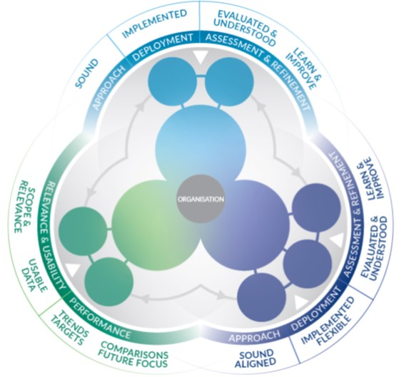

Direction

Criterion 1 - Purpose, Vision & Strategy
An outstanding organisation is defined by a Purpose that inspires, a Vision that is aspirational and a Strategy that delivers.
The Purpose of the organisation:
- Explains why its work is important
- Sets the scene for it to create and deliver sustained value for its stakeholders
- Provides a framework in which it takes responsibility for its contribution to, and impact on, the ecosystem in which it operates.
The Vision of the organisation:
- Describes what the organisation is attempting to achieve in the long-term
- Is intended to serve as a clear guide for choosing current and future courses of action
- Provides, along with the organisation’s Purpose, the basis for setting the Strategy.
The Strategy of the organisation:
- Describes how it intends to fulfil its Purpose
- Details its plans to achieve the strategic priorities and move closer to its Vision.

1.1 | Define Purpose & Vision |  | Ref. 1.1 (b&d)
1.1.1. Defines a Purpose that provides an inspirational motive for the importance and value of its work and is appealing to all its stakeholders?
1.1.2. Involves its stakeholders in defining, shaping and communicating its Purpose and Vision?
Approach
Deployment
Assessment & refinement
Results linkage

1.2 | Identify & Understand Stakeholders Needs |  | Ref. 1.2 (a&e)
1.2.1. Identifies the stakeholders and their needs and expectations within its ecosystem and prioritises on those that it sees as the Key Stakeholders, i.e. those with the potential to help or hinder the achievement of the Purpose, Vision and Strategy?
1.2.2. Studies and understands Key Stakeholder competences and strategies and responds appropriately to how these could affect its Purpose, Vision, Strategy, and business model?
Approach
Deployment
Assessment & refinement
Results linkage

1.3 | Understand the Ecosystem, own Capabilities & Major Challenges |  | Ref. 1.3 (a&e)
1.3.1. Researches and understands the ecosystem, including Megatrends, and the consequences on it of the United Nations Sustainable Development Goals and Global Compact ambitions and analyses different scenarios, current and future capabilities and market-place dynamics?
1.3.2. Assesses and evaluates the data, information and knowledge gathered from across its data to understand the major challenges for today and in the future?
Approach
Deployment
Assessment & refinement
Results linkage

1.4 | Develop Strategy |  | Ref. 1.4 (a&b)
1.4.1. Develops Strategy and a set of related strategic priorities that tackle any major challenges identified, making sure appropriate action is taken when necessary and actioned to set the pace within its ecosystem?
1.4.2. Translates Strategy and strategic priorities into performance targets and transformation initiatives?
Approach
Deployment
Assessment & refinement
Results linkage

1.5 | Design & Implement a Governance & Performance Management System |  | Ref. 1.5 (a&d)
1.5.1. Designs and implements a governance and performance management system that aligns with its aspirations and addresses the Strategy, developments in the ecosystem, own capabilities and major challenges?
1.5.2. Ensures performance and transformation management and measurement reporting systems are built into the organisation’s way of working to enable timely accountability and transparency with Key Stakeholders?
Approach
Deployment
Assessment & refinement
Results linkage

Criterion 2 - Organisational Culture & Leadership
Organisational Culture is the specific collection of values & norms that are shared by people and groups within an organisation that influence, over time, the way they behave with each other and with Key Stakeholders outside the organisation.
Organisational leadership relates to the organisation as a whole rather than any individual or team that provides direction from the top. It is about the organisation acting as a leader within its ecosystem, recognised by others as a role model, rather than from the traditional perspective of a top team managing the organisation.
In an outstanding organisation, leadership is positioned as an activity not a role and leadership behaviours are evident across all levels and parts of the organisation. This role model leadership behaviour inspires others, reinforces, and when necessary, adapts the values and norms, helping to steer Organisational Culture.
An organisation that aspires to be recognised as outstanding, a leader within its ecosystem, achieves success through a focus on the following activities.

2.1 | Steer the Organisation’s Culture & Nurture Values |  | Ref. 2.1 (a&b)
2.1.1. Understands and steers the culture to align with its Purpose and recognises when there is a need for the culture to be adapted?
2.1.2. Nurtures its values, translating these into desired norms & behaviours that it promotes, communicates and clearly demonstrates through its actions?
Approach
Deployment
Assessment & refinement
Results linkage

2.2 | Create the Conditions for Realising Change |  | Ref. 2.2 (b&c)
2.2.1. Creates the conditions where a “no-blame” attitude and space for trying, making mistakes and learning from them can flourish?
2.2.2. Facilitates a spirit of learning in the pursuit of its Strategy, encouraging the improvement and, at times, transformation of the organisation?
Approach
Deployment
Assessment & refinement
Results linkage

2.3 | Enable Creativity & Innovation |  | Ref. 2.3 (a&d)
2.3.1. Understands the importance and benefits of having a focus on creativity, innovation and disruptive thinking to help it achieve its Purpose, Vision and Strategy and set relevant goals and targets for these?
2.3.2. Develops the culture for, and expertise in, using the tools and techniques that facilitate improvement?
Approach
Deployment
Assessment & refinement
Results linkage

2.4 | Unite Behind & Engage in Purpose, Vision & Strategy |  | Ref. 2.4 (a&c)
2.4.1. Invests in making sure its Purpose, Vision and Strategy are communicated effectively to Key Stakeholders, helping to create an atmosphere of openness, trust, confidence and commitment?
2.4.2. Conveys to Key Stakeholders the impact and relevance of their specific contributions to the Purpose, Vision and Strategy, explaining the importance of gaining and maintaining their engagement?
Approach
Deployment
Assessment & refinement
Results linkage

Execution

Criterion 3 - Engaging Stakeholders
Having decided which Stakeholders are the most important to the organisation, i.e. its Key Stakeholders, and independent of the specific groups identified, it is highly likely that there is a degree of similarity in applying the following principles when engaging with Key Stakeholders.
An outstanding organisation:
- Identifies the specific types and categories within each of its Key Stakeholder Groups
- Uses its understanding of Key Stakeholders needs and expectations to achieve continued engagement
- Involves Key Stakeholders in deploying its Strategy and Creating Sustainable Value and recognises the contributions they make
- Builds, maintains and further develops the relationship with Key Stakeholders based on transparency, accountability, ethical behaviour and trust
- Works with its Key Stakeholders to develop a common understanding and focus on how, through co-development, it can contribute to, and draw inspiration from, the United Nations Sustainable Development Goals and Global Compact ambitions
- Actively gathers the perceptions of its Key Stakeholders rather than waiting for them to make contact.
- Evaluates its performance in relation to Key Stakeholders needs and decides on the appropriate actions to be taken to help secure its future, as perceived by these Key Stakeholders.

3.1 | Customers: Build Sustainable Relationships |  | Ref. 3.1 (a&d)
3.1.1. Identifies and classifies its customers based on defined criteria, e.g. social characteristics, needs and expectations, buying and user behaviour?
3.1.2. Establishes communication channels that make it easy for customers to interact, give feedback on their experiences and for the organisation to react quickly and appropriately?
Approach
Deployment
Assessment & refinement
Results linkage

3.2 | People: Attract, Engage, Develop & Retain |  | Ref. 3.2 (a&b)
3.2.1. Develops a People strategy and plans that support the overall strategy and plans of the organisation?
3.2.2. Adapts to the evolving needs and expectations of its People, both current and future, taking account, for example, of changing expectations on Organisational Culture & Leadership, gender balance & parity, diversity & inclusion and the desired working environment?
Approach
Deployment
Assessment & refinement
Results linkage

3.3 | Business & Governing Stakeholders – Secure & Sustain Ongoing Support |  | Ref. 3.3 (a&b)
3.3.1. Identifies the Key Business and Governing Stakeholders that have a financial, legal and general stewardship interest in the organisation and understands their expectations?
3.3.2. Involves Key Business and Governing Stakeholders in the development of its improvement & transformation ambitions and overall strategic direction?
Approach
Deployment
Assessment & refinement
Results linkage

3.4 | Society: Contribute to Development, Well-Being & Prosperity |  | Ref. 3.4 (a&b)
3.4.1. Uses its Purpose, Vision & Strategy to develop a clear understanding and focus on how it will contribute to its Society?
3.4.2. Establishes, develops and maintains a relationship with the Key Stakeholders in its Society, leading to mutual benefit for both the organisation and its Society?
Approach
Deployment
Assessment & refinement
Results linkage

3.5 | Partners & Suppliers: Build Relationships & Ensure Support for Creating Sustainable Value |  | Ref. 3.5 (a&b)
3.5.1. Segments its Key Partners and Suppliers in line with its Purpose, Vision and Strategy?
3.5.2. Ensures its Key Partners and Suppliers act in line with the organisation’s Strategy and that mutual transparency, integrity, and accountability in the trusting relationship is established and enhanced?
Approach
Deployment
Assessment & refinement
Results linkage

Criterion 4 - Creating Sustainable Value
An outstanding organisation recognises that Creating Sustainable Value is vital for its long-term success and financial strength.
The organisation’s clearly defined Purpose, enriched by the Strategy, defines for whom the organisation should be Creating Sustainable Value. In most cases, customers, segmented appropriately, are the target group for Creating Sustainable Value, although some organisations might also focus on selected Key Stakeholders within its Society or Business & Governing Stakeholder segments.
An outstanding organisation acknowledges that Key Stakeholder needs may change over time and that it is important to collect and analyse feedback to improve or change their products, services or solutions.
The different elements to Creating Sustainable Value are shown below in a step by sequence. It is recognised that the organisation’s plans for today and the future may well run in parallel or overlap at times, depending on the nature of the organisation’s business.

4.1 | Design the Value & How it is Created |  | Ref. 4.1 (a&c)
4.1.1. Understands what differentiates it from others, including, where relevant, its competitors, and makes these differentiators an integral part of the value it creates?
4.1.2. Develops the portfolio of its products, services and solutions in line with its Purpose and the current and future needs of existing and potential target groups?
Approach
Deployment
Assessment & refinement
Results linkage

4.2 | Communicate & Sell the Value |  | Ref. 4.2 (a&c)
4.2.1. Expresses the differentiators and the value propositions into attractive and engaging messages that are then communicated to existing and potential customers as well as other target groups?
4.2.2. Uses dedicated strategies and approaches to sell to target groups its differentiators and the value proposition(s) as well as the products, services and solutions?
Approach
Deployment
Assessment & refinement
Results linkage

4.3 | Deliver the Value |  | Ref. 4.3 (b&c)
4.3.1. Delivers sustainable value, as promised, through its portfolio of products, services and solutions and by meeting or exceeding the needs and expectations of its target groups?
4.3.2. Delivers its products, services and solutions in a way that minimises negative social and environmental impact?
Approach
Deployment
Assessment & refinement
Results linkage

4.4 | Define & Implement the Overall Experience |  | Ref. 4.4 (d&e)
4.4.1. Makes sure its people have the necessary resources, competencies and empowerment they need to maximise the overall experience for its target groups?
4.4.2. Designs, implements and uses timely feedback systems to improve the different phases of value creation as well as the products, services and solutions offered by the organisation?
Approach
Deployment
Assessment & refinement
Results linkage

Criterion 5 - Driving Performance & Transformation
Now and in the future, an organisation needs to be able to meet the following two important requirements at the same time to become and remain successful.
On the one side, it needs to continue managing successfully the delivery of its current business operations. (“Driving Performance.”)
On the other side, there are constant changes inside and outside the organisation that need to be managed in parallel if it is to remain successful. (“Driving Transformation.”)
The combination of Driving Performance & Transformation confirms the necessity for the organisation to deliver for today while preparing for the future.
Major elements in enabling performance & transformation are innovation and technology, the ever-increasing importance of data, information & knowledge and the focussed use of critical assets and resources.

5.1 | Drive Performance & Manage Risk |  | Ref. 5.1 (b&d)
5.1.1. Uses the performance management system to guide informed, effective, responsive and fact-based improvements?
5.1.2. Identifies risk and assesses the potential impact on the strategic priorities, the way things are executed and the desired results as well as potential opportunities?
Approach
Deployment
Assessment & refinement
Results linkage

5.2 | Transform the Organisation for the Future |  | Ref. 5.2 (b&c)
5.2.1. Identifies the transformation and change needs, taking into account its Purpose, Strategy, Sustainable Value Creation objectives and Results and scanning its ecosystem to forecast the main challenges and opportunities for the future?
5.2.2. Builds its organisational structure to best serve its Purpose, Vision and Strategy and considers innovative approaches to adapting its current organisational design based on the main challenges and opportunities that are forecast?
Approach
Deployment
Assessment & refinement
Results linkage

5.3 | Drive Innovation & Utilise Technology |  | Ref. 5.3 (b&c)
5.3.1. Takes advantage of innovations that support improvement in the current business and the need for transformation in the future?
5.3.2. Evaluates and exploits the potential that new technologies have to support ongoing value creation, improvements to its infrastructure and the responsiveness and adaptability of its processes & projects?
Approach
Deployment
Assessment & refinement
Results linkage

5.4 | Leverage Data, Information & Knowledge |  | Ref. 5.4 (a&c)
5.4.1. Ensures it has identified the data it needs to support its transformation plans as well as managing the products, services and solutions it currently offers, and is proficient in acquiring any essential information that may be lacking?
5.4.2. Converts data into information and knowledge and uses the outcomes to identify potential opportunities for creating further sustainable value?
Approach
Deployment
Assessment & refinement
Results linkage

5.5 | Manage Assets & Resources |  | Ref. 5.5 (a&b)
5.5.1. Uses financial resources in a balanced and sustainable way to help ensure current success and investment in the future?
5.5.2. Identifies and manages responsibly, the critical assets and resources that are vital for its Strategy, Performance and Transformation needs, including financial assets (cash, capital, investments), tangible assets (trading infrastructure, such as supply chain, real estate, technology and machinery) and intangible assets (proprietary data, self-developed software/technology, brand, goodwill, patents)?
Approach
Deployment
Assessment & refinement
Results linkage

Results

Criterion 6 - Stakeholder Perceptions
This criterion concentrates on results based on feedback from Key Stakeholders about their personal experiences of dealing with the organisation – their perceptions. These perceptions could relate to past as well as current Key Stakeholders and could be obtained from a number of sources, including surveys, focus groups, ratings, press or social media, external recognition, advocacy, structured review meetings, investor reports and compliments/complaints, including feedback compiled by customer relationship management teams.
In addition to the perceptions that a Key Stakeholder may have of an organisation based on personal experiences, perceptions may also be shaped by the environmental and social impact reputation of the Organisation. For instance, the degree to which the organisation is perceived by its Key Stakeholders as contributing successfully to one or more of the United Nations Sustainable Development Goals and Global Compact ambitions.
In practice, we find that an outstanding organisation:
- Knows how successful it is at executing its Strategy to meet the needs and expectations of its Key Stakeholders
- Uses its analysis of past and current performance to predict future performance
- Uses Key Stakeholder Perception Results to stay informed and influence its current Direction and the Execution of its Strategy.

Examples of Key Stakeholder Perception Results and topics to be covered could include, but are not listed in any priority order or limited to:
- Customer Perception Results
- People Perception Results
- Business & Governing Stakeholders Perception Results
- Society Perception Results
- Partners & Suppliers Perception Results

Stakeholder Perception Results |  | Ref. Criterion 6
Please list metrics and data below, adding the data itself where possible, showing current performance relating to stakeholder perception results, these may include but are not limited to the examples given above.
Metric / Data | Performance (of the Results) – add graph / chart / reference etc. or description

Criterion 7 - Strategic & Operational Performance
This criterion concentrates on results linked to the organisation’s performance in terms of:
- The ability to fulfil its Purpose, deliver the Strategy and Create Sustainable Value
- Its fitness for the future.
These results are used by the organisation to monitor, understand and improve its overall performance and to forecast the impact this performance will have on both the perceptions of its Key Stakeholders as well as its future strategic ambitions.
In practice, we find that an outstanding organisation:
- Uses both financial and non-financial indicators to help it measure its strategic and operational performance
- Understands the linkages between Key Stakeholder perceptions and actual performance and is able to predict, with a high degree of certainty, how future performance will evolve
- Considers the current and future needs and expectations of its Key Stakeholders when deciding on the most appropriate performance indicators to match its strategic & operational objectives
- Understands the cause and effect relationships that impact on performance and uses the results achieved to stay informed and influence its current Direction & Execution
- Uses the results currently being achieved to forecast its future performance with an expected degree of certainty.

Strategic and Operational Performance indicators, could include, but are not limited to:
- Achievements in delivering its Purpose and Creating Sustainable Value
- Financial Performance
- Fulfilment of Key Stakeholders Expectations
- Achievement of Strategic Objectives
- Achievements in Driving Performance
- Achievements in Driving Transformation
- Predictive Measures for the Future.

Strategic & Operational Performance Results |  | Ref. Criterion 7
Please list metrics and data below, adding the data itself where possible, showing current performance relating to Strategic & Operational Performance results, these may include but are not limited to the examples given above.
Metric / Data | Performance (of the Results) – add graph / chart / reference etc. or description

