Document ref. | RxP04
Version | 1b
Date | January 2021

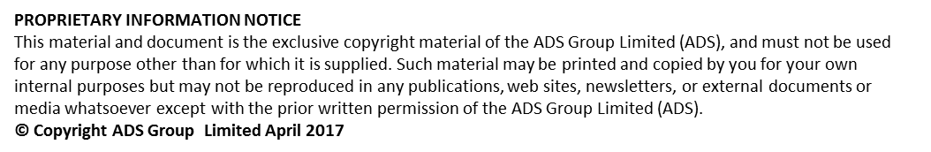

Document History
Document Location |  |  | SC21 Project Office

Version History
 | Version date | Date of previous version |  | Version | Author(s) | Summary of Changes | Approved by
 | Jan 13 | Nil |  | 1 | Unknown | RMM Facilitators Guidance Note Issue 1 jan 2013 | Unknown
 | Jun 19 | Jan 13 |  | 1a | David Singleton | Update – Contents/Format/Doc Name
 | Jan 21 | Jun 19 |  | 1b | Marika De Rosa | Update – Contents/Format/Doc Name

Scope of Applicability
SC21  Lite | SC21  OE | SC21  C&G
Y | Y | N
Associated documents to be referred to | Issue | Date
RxP04 - RMM Facilitators Guidance Note Issue 1 Jan 2013
RxP05 - RMM User Guide Issue 1 Jan 2013
RelEx Process guide
RelEx assessment
Code of Practice
RMR/RMM Question S/Sheet
RMR/RMM Analysis S/Sheet
RMR Planning checklist
RMR Workshop Checklist
RMR Workshop Agenda

Relationship Management Review – User Guide
Introduction
The Relationship Management Review process is a systematic approach for developing and managing key partnerships. It focuses on joint growth and value creation, is based on trust, open communication, empathy and a win_win orientation.
Organisations who want to drive business results through the development of collaborative working relationships can benefit from deploying such relationship tools, techniques and philosophies.
The SC21 Supply Chain Relationship Code of Practice establishes the philosophies and guidelines by which organisations can work together to achieve sustainable benefit.
The SC21 Relationship Excellence Framework helps organisations to improve their collaborative working capability by defining, developing and prioritising approaches for each of their key relationships. Some which will require a very close collaborative approach and others that are more transactional and distant.

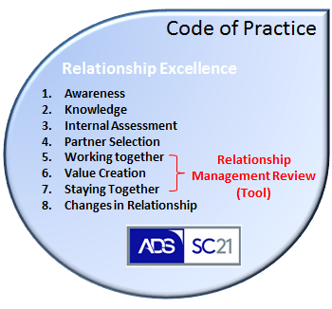
The SC21 Relationship Management Review (RMR) is a tool set that organisations can use to measure the performance of their relationships with partner/partners using a standard set of questions aligned to the principals defined within the code of practice.
The process will facilitate joint improvement opportunities that will contribute towards common objectives and agreed targets in order to achieve the desired relationship future state between partner(s).
The RMR process is based on the principle of “Plan, Do, Review”, it’s easy to understand toolkit, deployment can vary (one to one or one to many Relationships) and is therefore applicable to all stages of relationship development or management and at all stages of the project/product lifecycle.
Considerations to the scope and scale of activities undertaken will be determined by factors such as maturity and complexity of existing relationships, risk implications, levels of stakeholder engagement, overall strategic direction, relationship classification and priority.
Low ( Risk ) High
Strategic
High value Business Critical
Collaborative thinking
Growth potential

Complex
Developing joint value
Multiple interfaces
Large projects

Developing
New relationship
Leading edge technology
Expert to expert engagement

Developing potential
Stable
Established programmes
Low variation
Optimal engagement

*Strategic and more complex relationships may require facilitation from an independent and/or approved SC21 facilitator. *Low risk and developing relationships can be facilitated by local/deploying entities that are independent from the relationship.
One of the critical success factors when undertaking a relationship management review is obtaining senior or executive sponsorship. This will be someone whom has a vested interest in the success of the process, authority to remove obstacles and encourage openness whilst driving accountability through action and improvement.
Typical benefits to deploying a RMR:
- Improves understanding of customer requirements and expectations
- Encourages open communication, trust, transparency and co-operation
- Highlights joint improvement initiatives and define the improvement path
- Supports joint issue resolution, reduce risk & improve performance (QCD)
- Provides a forum to identify (anonymously) and air relationship problems between partners in semi-formal environment

Planning
In order to achieve a successful relationship management review workshop, it’s important to have completed the necessary preparation during the planning phase. You may find the planning checklist helpful in managing key activities leading up to the workshop.
- Agreed scope of activity for example i.e. specific sites or business units
- Agreed stakeholder map including sponsorship (stakeholder typical include member form both sides Account management, Quality, Engineering and Production departments)
- Awareness presentation
- Issued agenda and timing plan
- Issued question set with analysis expectations

The question set focuses on four elements of the relationship, each with five key attributes:
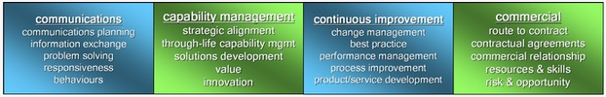

Relationships are assessed, and improvements measured, against their desired type/state (failing, reactive, operational, cooperative or collaborative) which may change over time.

Stakeholders are encouraged to look at the descriptors for each of the attributes being assessed and to select the one that is most appropriate to their specific relationship(s).

Analysis
Once the questions have been issued and returned to the facilitator, the data can be compiled and analysed using the RMR-Questionnaire Analysis Workbook. It’s important to identify the key differences in the relationship and scoring and identify any outliers that may skew the results.
Further discussion may be required to clarify points and scores and this may help to draw out some of the issues affecting the relationship.
The RMR analysis workbook automatically generates 3 charts
1. 0’s and 1’s charts illustrating participants who have identified the relationship as “Failing / Disengages” (Score - 0) or “Reactive” (Score - 1) against any of the criteria measured.
2. Gap analysis chart which shows the average score between partners
3. Relationship status chart (Spider diagram) which shows the combined score relative to the 5 sections.
Three key points to remember:
- Establishing a consensus can be difficult but differences in perception will provide material for debate.
- Encourage reinforcement of poor perceptions with comments.
- Don’t get hung up on the numbers game, focus on the relationship state.

Workshop
This activity can be conducted as part of a joint review such as a strategic/tactical business review or run as a separate 1-day RMR workshop. Enough time must be allocated to achieve the desired outcome and deliver the improvement plan. This may vary due to the complexity and scale of the relationship. Remember to set the scene with senior sponsorship endorsement especially in more complex relationships.
Use the agenda to control timings and focus delivery. Work towards an agreed consensus “As Is” current state as this will baseline the relationships starting position and will enable future comparisons to be made. Deep dive into areas highlighted during the analysis phase to stimulate discussion and capture opportunities as they arise. Agree the future “To be” target sate and next review time line.
Three key points to remember:
- Use the comments from the analysis workbook to facilitate debate
- Use gaps in the perception to stimulate discussion
- Capture opportunities as outputs to the discussions

Improvement
Review opportunities as a conclusion to the workshop and explore improvement actions. Allocate ownership and a desired completion time frame. This forms the basis of the improvement plan or CSIP. Actions should focus on overcoming the perception gaps and addressing those issues that are perceived to be holding‐back the relationship. Equally, there may be issues that the key stakeholders are keen to promote in the relationship and actions should support those.
When prioritising issues/actions it may be useful to consider how easy or difficult the improvement action will be to implement against the level of benefit anticipated.
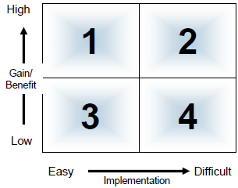
Actions that are easy to implement and will deliver high benefit should be treated as priority; these quick wins can also be useful to demonstrate the value of the process and to ensure support for further action.
Actions that may be more difficult to implement but will deliver substantial benefit will require strong sponsorship and should be regularly reviewed as part of the Relationship Management Plan.
Three key points to remember:
- Turn opportunities into action and prioritise
- Allocate ownership with completion dates
- Arrange a follow up

